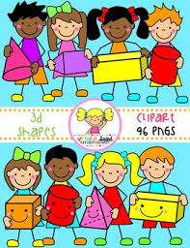Primary 1 Home Learning Work From Miss Hall

Week 8 Wed 27th May 2020

Hello Primary 1, here are some activities for you to try today.

To access the Twinkl documents you first have to sign up for a free membership account:

1. Go to [www.twinkl.co.uk/offer](http://www.twinkl.co.uk/offer)
2. Sign up for a free account (entering parent as occupation)
3. Enter the offer code UKTWINKLEHELPS

Practical Maths

I can explore and learn about Capacity to find out what different objects can hold.

* Click on the website <https://www.twinkl.co.uk/resource/t-n-2545298-eyfs-potions-capacity-powerpoint> **to work on the activities**
* **Click on https**://www.twinkl.co.uk/resource/capacity-quiz-t-m-3633 and try slides 2, 3, 4 and 5 please

**Capacity Activities to Try**

**Use small stones, cubes or pieces of lego to fill the cups in this game called Fill Your Cup.**

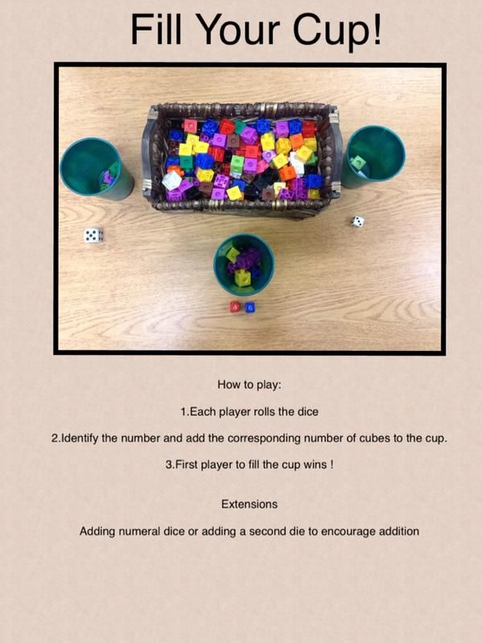

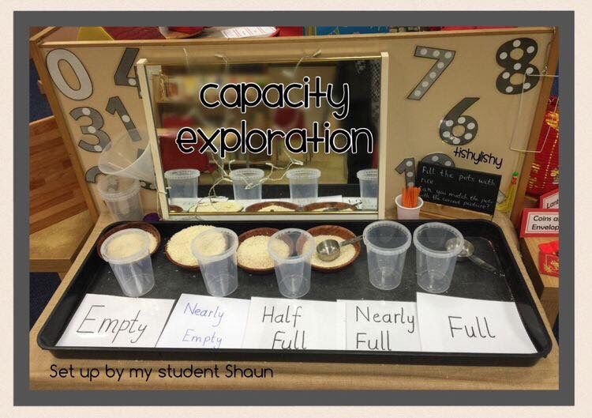

* **Can you find 5 plastic containers, empty yoghurt pots or empty plant pots which are about the same size?**
* **Please ask a grown up to help you write these words on your labels – Empty, Nearly Empty, Half Full, Nearly Full and Full**
* **Place the labels in front of each pot in the same order as the picture**
* **Use sand, dried rice, dried pasta or water to fill your pots to match each label**
* **Mix up your labels, then try to rearrange your pots to match them**
* **You can try mixing them up again if you want to do this**

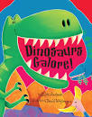



**Story and Music Time**

**I can listen to the story, make predictions and learn new vocabulary.**

**I can participate and enjoy singing and performing to the music**

* **Enjoy listening to the story** [**https://www.youtube.com/watch?v=3_SohxFRb7E**](https://www.youtube.com/watch?v=3_SohxFRb7E) **called Dinosaurs Galore by Giles Andreae.**
* **Click onto** [**https://www.youtube.com/watch?v=9XQSFLMpn_c**](https://www.youtube.com/watch?v=9XQSFLMpn_c) **to enjoy the song called**
* **10 Little Dinosaurs and have fun doing the actions.**

Literacy

I can learn how to write the formation for the Capital E and F letters.

* [https://www.twinkl.co.uk/resource/t-l-8548-upper-and-lowercase-letter-formation- powerpoint](https://www.twinkl.co.uk/resource/t-l-8548-upper-and-lowercase-letter-formation-%20%20%20%20%20%20powerpoint)
* Scroll down and select the Capital E slide and try this 5 times by clicking onto the pencil
* Now make this letter in the air with your finger, then on the floor 5 times
* Scroll down and select the Capital F slide and try this 5 times by clicking onto the pencil
* Now make this letter in the air with your finger, then on the floor 5 times
* Use **Flour, Salt, or Sand Writing**. Choose the one you want to use.
* Write the letter **E and F** using your finger or a paintbrush. Put coloured paper under the flour/salt or sand to make the letter stand out
* Try this 3 times for each letter please on different plates
* 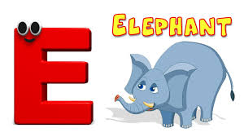**Play the I Spy Game** – How many things in your house can you see that begin with **E and F?**

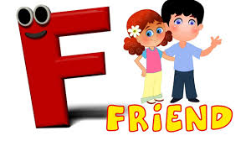

Litracy

I can use my knowledge of sounds, letters and patterns to read words. I can learn about the oo sound from these activities.

.

* Click onto <https://www.youtube.com/watch?v=sBCWHP6OOpc> **to listen to words with the long oo sound and use your ‘sound box’ to help you say the words**
* **Click on** <https://www.twinkl.co.uk/resource/adaptation-powerpoint-t-l-9473> **to try these activities**
* **Try the think and read words then complete the challenge sentences in the game**

**oo oo oo oo oo oo oo oo**

**French**

I can learn about the names of some colours in French and learn how to say them.

* Click on <https://www.youtube.com/watch?v=JkQGN86qTag> to listen to Learn French Through Music in One Minute
* Repeat the colours in French as you listen
* Click onto <https://www.youtube.com/watch?v=WZWN2Uragvc> to listen to the Rainbow Song in French
* Please play the song 2 or 3 times and join in with the words
* Draw 4 pictures and use a different colour for each one
* Can you write the French word for your colour underneath it?
* Here are two examples to show you

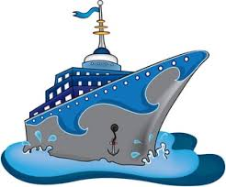

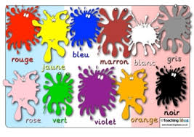 rouge bleu