Outdoor or Indoor Scavenger Hunt
Each time you find an item on your hunt tick it off
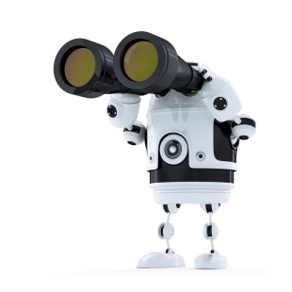
and do 5 star jumps!
Can you find something to ……………

that is heavy

to jump over

to crawl under

that is smooth

that is rough

that is loud

to play catch with

that is hard

that is squishy

to roll across the ground

