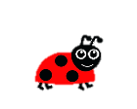

I can describe characteristics of living things and how they depend on each other.

Bee hive

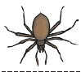

flowers

Draw a line from the Minibeast to the correct habitat.

Spider web

Ant hill

Sitting on leaves

