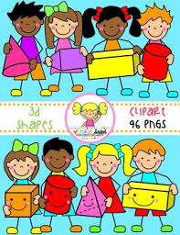
Primary 1 Home Learning Work From Miss Hall
Week 7 Friday 22nd May 2020
Hello Primary 1, here are some activities for you to try today.
To access the Twinkl documents you first have to sign up for a free membership account:
- Go to www.twinkl.co.uk/offer
- Sign up for a free account (entering parent as occupation)
- Enter the offer code UKTWINKLEHELPS
Practical Maths
I can learn how to say the days of the week with this fun activity.
- Click onto https://www.bbc.co.uk/bitesize/topics/zrqqtfr/articles/ztjg39q
- Listen to the clip then scroll down to complete the next 3 activities including the quiz
- Select https://www.twinkl.co.uk/resource/t-c-1206-days-of-the-week-display-poster to help you
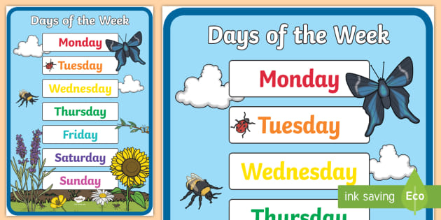
- Click https://www.topmarks.co.uk/Search.aspx?Subject=16&AgeGroup=2 and select Year 1 Maths – Year 1 – Time R.12 – Select Days of the Week to play the game
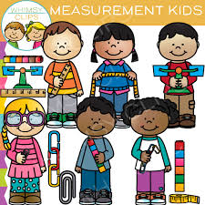

- Please try these Measurement Games to revise some of the work you have been learning this week
- Click on https://www.topmarks.co.uk/Search.aspx?Subject=16&AgeGroup=2 and select Year 1 Maths – Year 1 – Measurement – U.2 – Tall and Short, U.3 – Wide and Narrow

- Literacy
I can enjoy playing some matching games to help me find letters, sounds and words I know.
- Enjoy this game by choosing https://www.twinkl.co.uk/go/resource/the-park-interactive-matching-activity-tg-383
- Click onto https://www.twinkl.co.uk/go/resource/tg-ga-157-level-3-phonics-game-show to help to revise some of your letters and sounds
- Choose this game to see if you can work out which object matches the sound https://www.twinkl.co.uk/resource/tg-ga-146-level-1-phonics-the-garden-environmental-sounds-game

Music
I can participate actively in songs, rhymes and stories.
- Click onto https://www.youtube.com/watch?v=Lql13as8yBk&list=PLtRI5Q1N9gAmehIGE6BgXgTEh8aDHiuwM&index=1 to join in with the action song Zooming to the Moon from Sticky Kids Productions
- Can you make up your own actions as you hear them with the music?
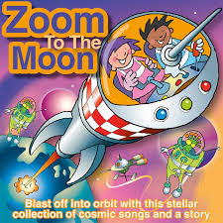

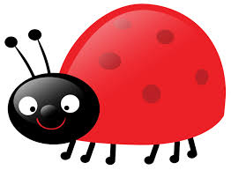
Story Time
- Click onto https://www.youtube.com/watch?v=Sl4QuS2SrTE to enjoy There’s No Place Like Space the Cat in the Hat Story.
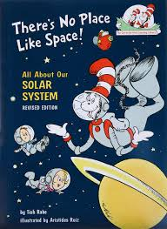

Assembly
Please ask a grown up to check their emails today and open up the assembly for this week.
Friday 22nd May in SWAY.

