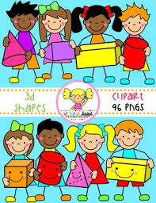Primary 1 Home Learning Work From Miss Hall

Week 7 Wed 20th May 2020

Hello Primary 1, here are some activities for you to try today.

To access the Twinkl documents you first have to sign up for a free membership account:

1. Go to [www.twinkl.co.uk/offer](http://www.twinkl.co.uk/offer)
2. Sign up for a free account (entering parent as occupation)
3. 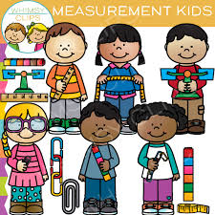Enter the offer code UKTWINKLEHELPS

Practical Maths

I can explore and learn about Measurement related to longer, shorter, taller and heavier.

* Click on the website <https://www.twinkl.co.uk/resource/t-n-45372-jungle-measuring-powerpoint> **to work on the activities**
* <https://www.twinkl.co.uk/resource/t-n-2546085-ks1-beanstalk-height-and-length-activity-powerpoint> **and try some of the ideas**
* Click on <https://www.topmarks.co.uk/early-years/lets-compare> and enjoy the games from At the Beach and Animals
* Use some small things from home like lego, bricks or crayons and try to arrange them in order of size – smallest to biggest or tallest to shortest



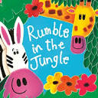



Story and Music Time

I can listen to the story, make predictions and learn new vocabulary.

I can participate and enjoy singing and performing to the music

* Enjoy listening to the story of <https://www.booktrust.org.uk/books-and-reading/have-some-fun/storybooks-and-games/rumble-in-the-jungle/>
* Click onto <https://www.youtube.com/watch?v=24TiN8Rr2Yg> **to enjoy the Hello Song and have fun doing the actions**

Literacy

I can learn how to write the formation for the Capital C and D letters.

* [https://www.twinkl.co.uk/resource/t-l-8548-upper-and-lowercase-letter-formation- powerpoint](https://www.twinkl.co.uk/resource/t-l-8548-upper-and-lowercase-letter-formation-%20%20%20%20%20%20powerpoint)
* Scroll down and select the Capital C slide and try this 5 times by clicking onto the pencil
* Now make this letter in the air with your finger, then on the floor 5 times
* Scroll down and select the Capital D slide and try this 5 times by clicking onto the pencil
* Now make this letter in the air with your finger, then on the floor 5 times
* Use **Flour, Salt, or Sand Writing**. Choose the one you want to use.
* Write the letter **C and D** using your finger or a paintbrush. Put coloured paper under the flour/salt or sand to make the letter stand out
* Try this 3 times for each letter please on different plates

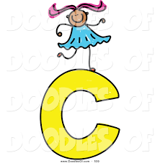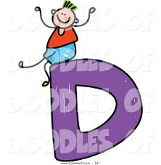

Litracy

I can use my knowledge of sounds, letters and patterns to read words. I can revise the oa sound.

.

* Click onto <https://www.youtube.com/watch?v=_xYKYTf0JS8> **to listen to words with the oa sound and use your sound box to help you say the words**
* Write 3 of these words with an oa sound on paper with felt pens, crayons or paints

**oa oa oa oa oa oa oa oa oa oa**

**French**

I can learn about some simple daily school routines in French with the parrot Papo.

* Click onto <https://www.bbc.co.uk/bitesize/clips/zbk3cdm> to listen to the ideas and join in with the French words
* Pause the clip each time to repeat each of the French words
* Write down any 3 of these French words from the clip and draw and colour the pictures which match them

https://ichef.bbci.co.uk/images/ic/112xn/p01h11zk.jpg

* 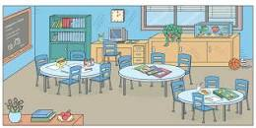**une regle – ruler**
* **un crayon – a pencil**
* **la sale de classe – classroom**
* **le dejeuner – lunch**
* **une gomme – a rubber**

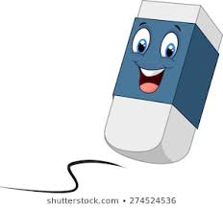

Try these words with your family!

bonjour merci au revoir