STEM Challenge – 1
Investigating Ice

Can you investigate the properties of ice using the following activities? These activities are suitable for all the family so you can work together.

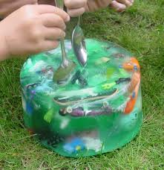
Task 1 - Explore
- Put a few items in a small container and then fill it with water. These could be small toys such as lego or natural resources such as stones.
- Put the container in the freezer and leave until the water is frozen.
- Remove the container from the freezer and leave it to sit for 5-10 minutes until the ice loosens and then tip it out onto a tray or plate.
How can you rescue your toy? Experiment with different methods.

Task 2 - Investigate
Using ice cubes can you investigate what is the best method to melt ice?
Choose one or more of these options to test:
- Temperature – leave ice cubes in a container in different place (in the sun, in the shade, in the fridge etc)
- Type of liquid – water, salt water, oil, milk
- Size of ice cube – do smaller ice cubes melt quicker?

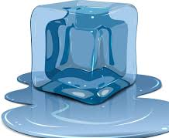
Learning Tools
Early Level – Nursery/P1
Allow your child to explore frozen block and take the lead from them. Some questions to ask your child to prompt learning:
- Can we use tools such as a spoon to rescue the toys?
- What happens if we pour cold water on the ice?
- What happens if we use warm water instead?
- Do you think salt will help the water melt?
- What is working the best?
- What would be the fastest way to rescue the toys?

First Level – P2/P3/P4
- Can you explain why the water has frozen? How do you know the water is frozen?
- Use the questions above to think about what you have learned in Task 1.
- What are you going to test in Task 2?
- What do you think the results will be?
- Can you record what happened? You could write a few sentences or draw a picture.
- What did you learn?

Second Level – P5/P6/P7
When completing the tasks use the following investigation tools:
- Prediction – What do you want to test? What do you think the results will be?
- Measuring – how can you measure your results? For example using a stopwatch.
- Fairness – How do you make sure your results are reliable? What will you keep the same in your experiments and what is the one thing you will change?
- Recording – How can you record your results?
- Conclusion – What have you learned from completing your experiments? What would you do differently next time?
Choose one of your experiments to share. You could write a report, take photos or make a poster.

