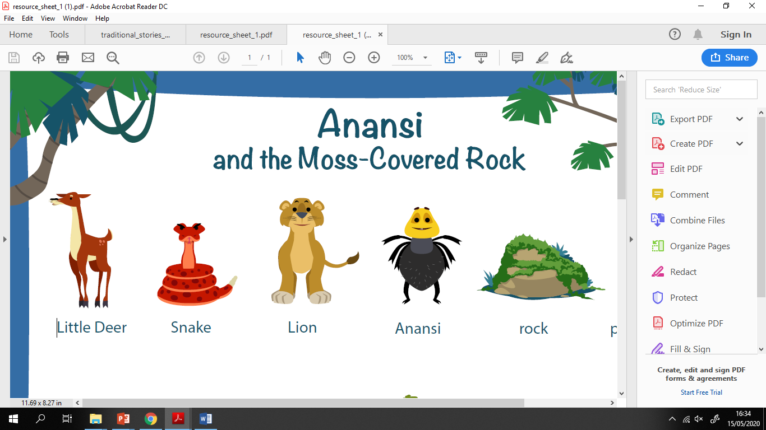 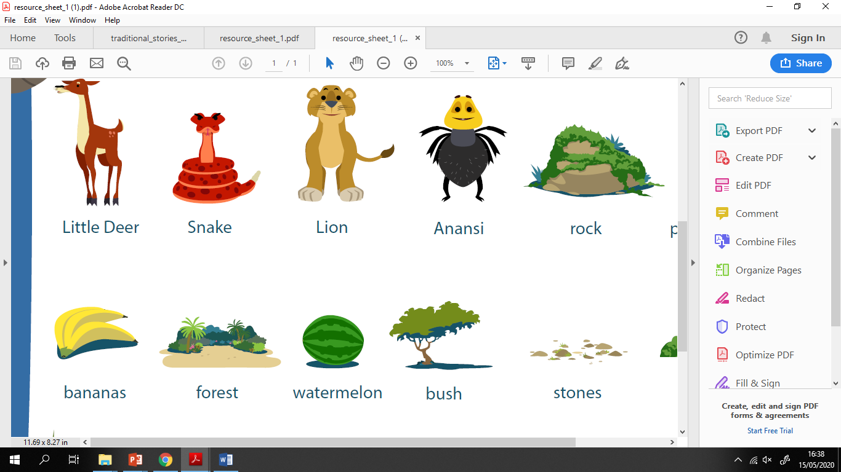

What will happen next in the story?

________________________________________________________________________________________________________________________________________________________________________