**Picture**

Minibeast Name - ______________________

Fact 1 ____________________________________________________________________________

Fact2 ____________________________________________________________________________

Fact 3

______________________________________

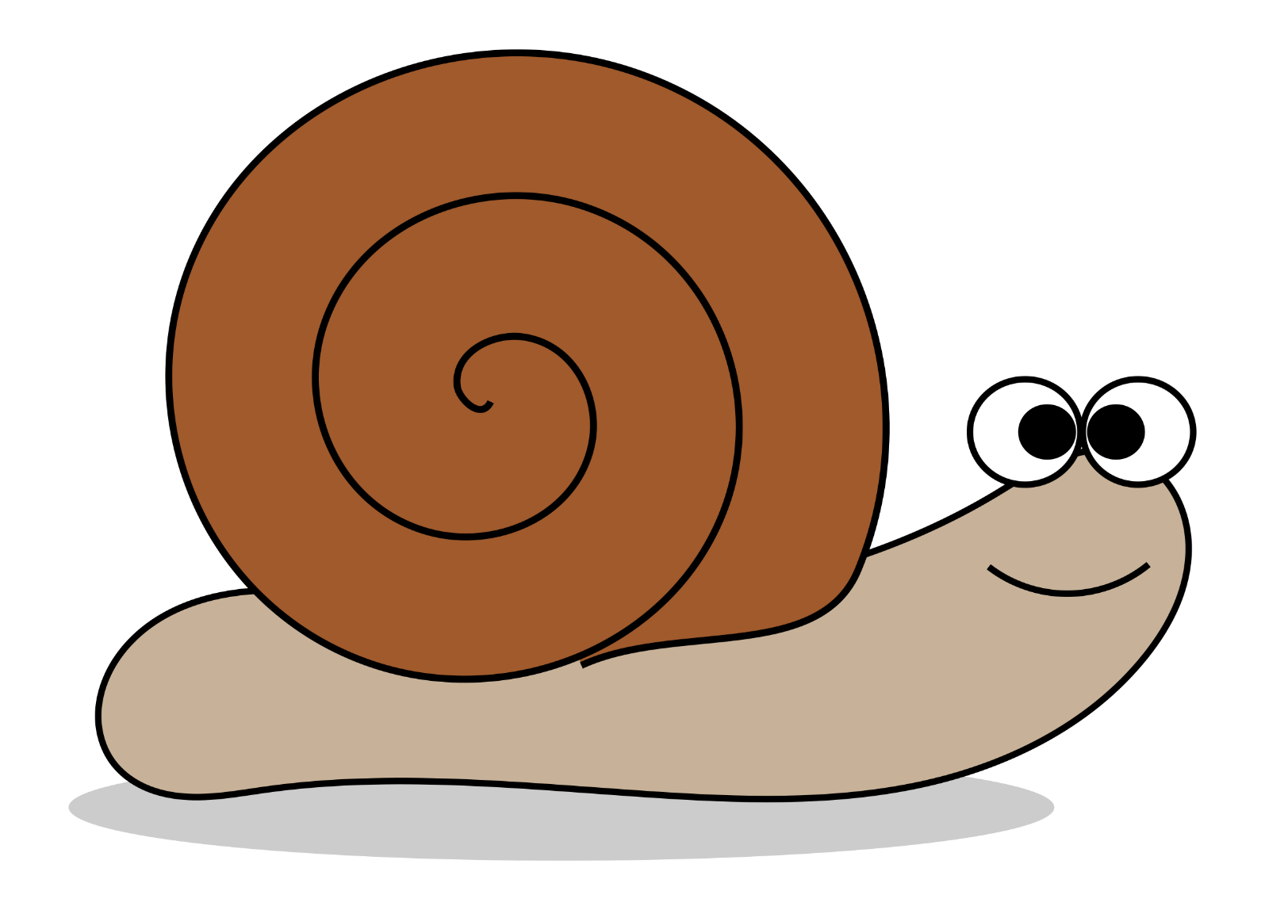 Minibeast Fact File 