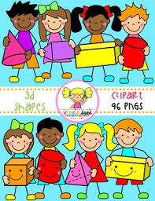
Primary 2 Home Learning Work From Miss Hall
Week 6 Thursday 14th May 2020
Hello Primary 2, here are some activities for you to try today.
To access the Twinkl documents you first have to sign up for a free membership account:
- Go to www.twinkl.co.uk/offer
- Sign up for a free account (entering parent as occupation)
- Enter the offer code UKTWINKLEHELPS

Practical Maths
Learning Intention – – I am learning to recognise Fractions divided into halves and quarters and use the correct words and symbols to show this.
- Click onto https://www.youtube.com/watch?v=i42H4f5vXDw to watch Making 1 with halves and Quarters Year 1
- Listen to https://www.bbc.co.uk/bitesize/clips/z6bq6sg fractions to show the link with everyday objects
- Click https://www.twinkl.co.uk/resource/t-n-1382-halves-and-quarters-fractions-worksheets
- You don’t need to print this sheet out but complete the work on paper and make up 3 examples of your own
- Enjoy the Pizza Fraction Game by clicking onto https://www.twinkl.co.uk/resource/tg-ga-92-pizza-fractions-game
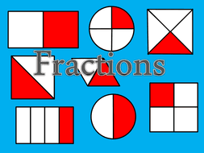
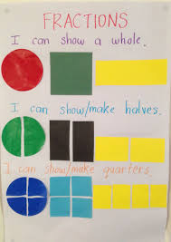

Literacy
Learning Intention – I can revise some of my Spelling Words, identify the patterns and write them carefully.
important body music sitting running shutting wedding splitting winning
- Read each of the words, clap the syllables then use your sound box to sound out the words
- Notice the short vowel followed by a double consonant in all the ing words
- For example – sitting winning
- Choose 4 of the words and write them carefully into your jotter
Learning Intention – I can learn to understand and recognise what an Adjective is and why we use these in our writing.
Finding Out About Using Adjectives
- Select the website https://www.bbc.co.uk/bitesize/topics/zrqqtfr/articles/zy2r6yc
- Click onto KS1 What is an Adjective? and listen to the clip, then read the information below this
- Now try the next clips called Highlight the Adjective and The Adjective Quiz
- Think about 4 words which describe your favourite toy or game and write them into your jotter in front of the name of your toy/game
- Use a coloured pen/pencil to write the adjective in front of the toy
- For example – fantastic jigsaw or amazing trampoline

Story Time
Learning Intention - I can listen to the story, make predictions and learn new vocabulary.
- Click on https://www.youtube.com/watch?v=7cYgxknuDmc to listen to the story called A House for a Hermit Crab by Eric Carle
Music
Learning Intention – I can participate and enjoy singing and performing to the music
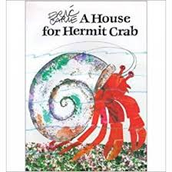
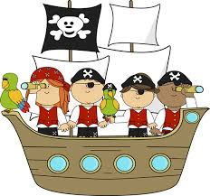
- Click onto https://www.youtube.com/watch?v=lCPJhybHBkA to enjoy and join in with the song Over the Deep Blue Sea

Art
Learning Intention – I can follow instructions to make my own Handprint Hermit Crab related to the story I have read called A House for a Hermit Crab.
- You need a paper plate, a sheet of paper or card, paints, a pipe cleaner, pieces of sponge, googly eyes and exciting bits and pieces to decorate your plate with
- Don’t worry if you don’t have all of this, just use what you have and your imagination!
- Look at the pictures on this page to help you with the instructions
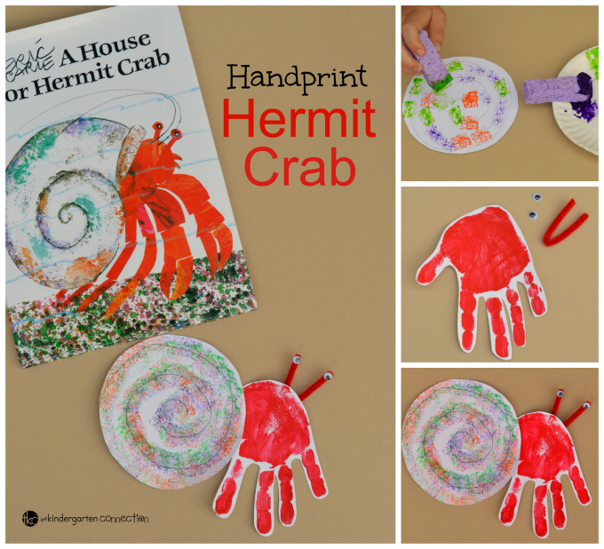
- Take a photo of your completed art work if you would like to do this

Instructions
- Apply paint to child’s hand and press onto a piece of white card/paper
- Allow to dry.
- Cut a circle out of white card or use a paper plate for the hermit crab’s shell
- Dab sponges in the paint and make swirl effects onto the crab’s shell
- You can glue on bits of coloured decoration as well
- Paint the child’s hand and press firmly onto a piece of paper
- While pieces are drying, cut a small piece from the pipe cleaner and fold in 1/2 to make each antenna then glue googly eyes to the ends of the pipe cleaner.
- Cut the handprint out once the paint has dried, cutting around the fingers.
- Attach the handprint to the shell of the hermit crab so that the fingers are pointing downwards. Attach the thumb to the back of the hermit crab’s shell.
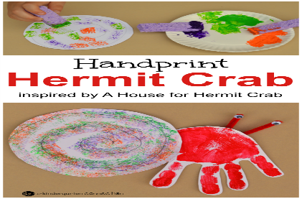
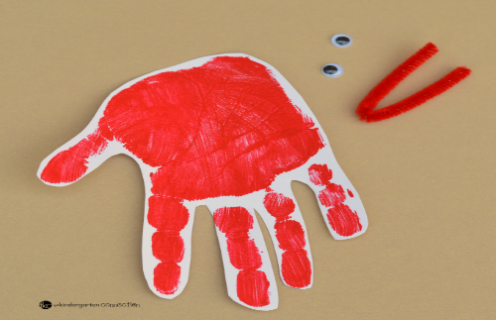
- Glue or tape the pipe cleaner to the back of the handprint so that the eyes stick out above the handprint.

