A Plan for Mrs Grinling
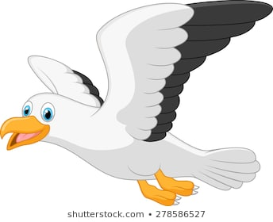
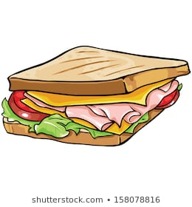
Poor Mr Grinling, the seagulls enjoyed the mustard sandwiches. Can you help Mrs Grinling think of a way to trick them? What could you put in the sandwiches?

________________________________________________________________________________________________________________________________________________________________

