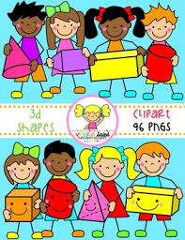Primary 1 Home Learning Work From Miss Hall

Week 6 Wed 13th May 2020

Hello Primary 1, here are some activities for you to try today.

To access the Twinkl documents you first have to sign up for a free membership account:

1. Go to [www.twinkl.co.uk/offer](http://www.twinkl.co.uk/offer)
2. Sign up for a free account (entering parent as occupation)
3. Enter the offer code UKTWINKLEHELPS

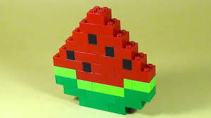

Practical Maths

I can explore, learn and identify patterns and explain what they are.

* Click on the website www.twinkl.co.uk.t-t-7245-int to pattern powerpoint to discuss the ideas
* **Do you see any objects around your home which have patterns in them? Chat about what you notice.**
* Click on <https://www.twinkl.co.uk/resource/tf-n-48-pretty-patterns-song-powerpoint> **to join in with the music and guess the next colour in the pattern**
* 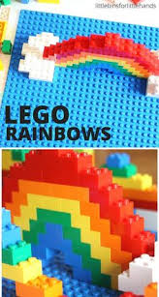 Create your own patterns from lego, cubes or other small objects and use this website to help you with ideas – t-t-11551-lego-Pattern-Challenge-Cards



Story and Music Time

I can listen to the story, make predictions and learn new vocabulary.

I can participate and enjoy singing and performing to the music

* Enjoy listening to the story of Pattern Bugs Read Aloud by Trudy Harris
* Click onto <https://www.youtube.com/watch?v=4g2fKY_mwYI> **to enjoy the story**
* 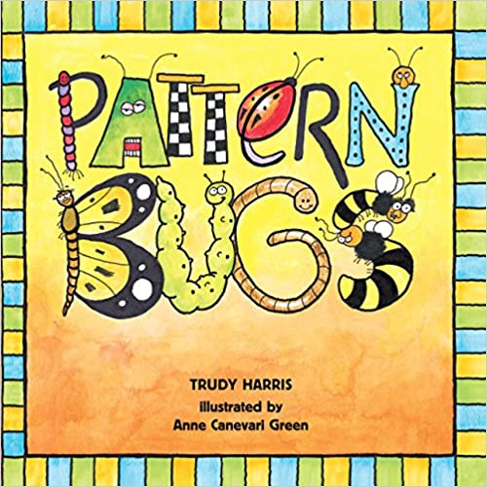Click onto <https://www.youtube.com/watch?v=hisZ9PLKWbM> **to join in with the song AAB Pattern Song – Musical Maths**

Literacy

I can learn how to write the formation for the Capital B letter.

* Click on https://www.twinkl.co.uk Home Learning Hub/resource/t-s-190-uppercase-a-z-letter-formation-worksheets and choose Capital B only
* Use a coloured pen or pencil to follow the letter formation for each letter
* Now try this **Flour, Salt, or Sand Writing**. Choose the one you want to use.
* Write the letter **B** using your finger or a paintbrush. Put coloured paper under the flour/salt or sand to make the letter stand out
* Try this 3 times please on different plates

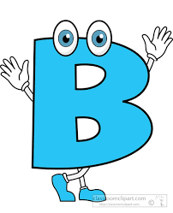



Litracy

I can use my knowledge of sounds, letters and patterns to read words. I can revise the igh sound.

.

* Click onto <https://www.bbc.co.uk/bitesize/topics/zvq9bdm/articles/zkhvhbk> **to listen to the** **igh sound and try the different activities which follow this**
* **Click onto**<https://www.youtube.com/watch?v=PY0dVgoH0uo> **to listen to the Phonics Blending igh Sounds Part 1 and use your sound box to help you say the words**
* Can you make 3 igh words outside using small pebbles, bark chippings, small leaves, chalks or other interesting things?
* If the weather is wet or cold, please use 4 colours and write them with **Rainbow Writing** instead please.

**igh igh igh igh igh igh igh**

**Art**

I can learn how to make pictures using a variety of different patterns and textures.

* Click on <https://www.youtube.com/watch?v=W66TAqCT4hc> to look at ways of making leaf rubbing pictures
* Choose some leaves from your own garden and make the rubbings by putting them underneath your paper
* Press hard with the side of the crayon and use coloured wax crayons or oil crayons
* Now try to look for different objects both inside and outside your home to make your own pictures
* Some of the things you can use outside could be walls, bricks, stone, a fence or the bark of a tree. What else do you notice?
* Inside you could use bubble wrap paper, a grater and items which have an interesting texture. Can you spot anything else?
* To do this, place the paper over the area or object, then use a wax crayon to rub it hard
* You can create lots of different patterns on one page like the images show you
* 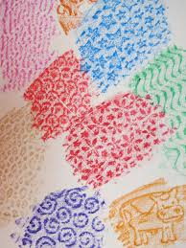Cut out some of the textures you have made to make them into a picture if you would like to do this
* 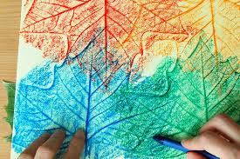Enjoy yourself and have fun!

