**PE at home – May 12**

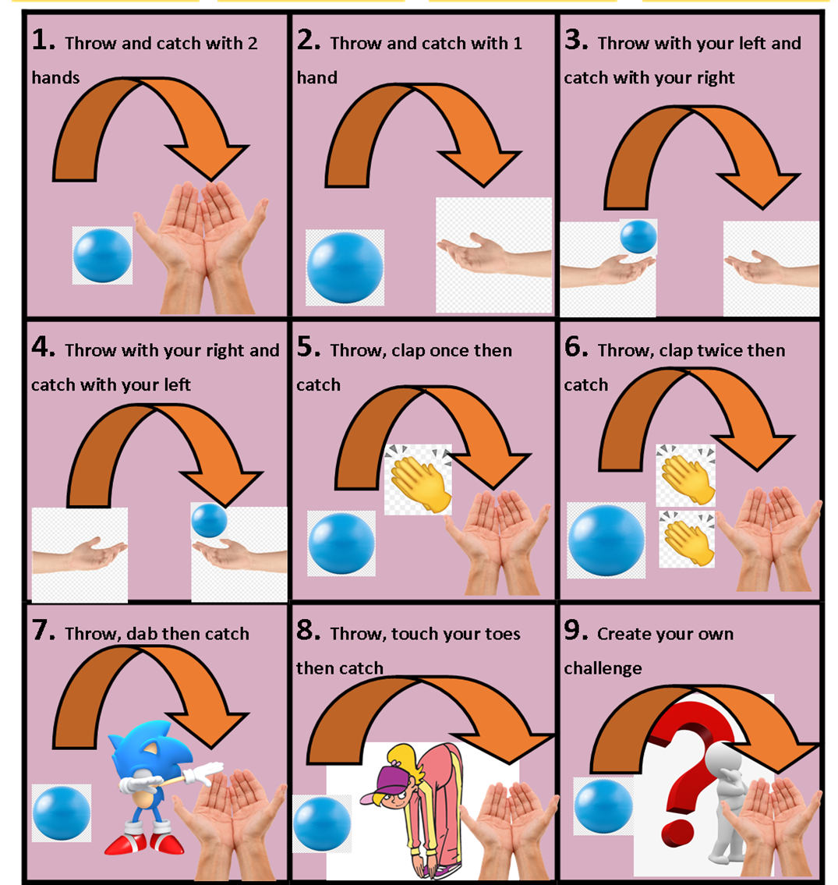

Throwing and Catching skills

You will need: a ball or a pair of balled up socks.

Do not worry if you drop the ball, just keep practising!