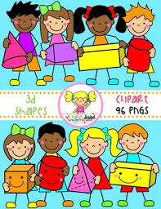
Primary 1 Home Learning Work From Miss Hall
Friday 8th May 2020
Hello Primary 1, here are some activities for you to try today.

To access the Twinkl documents you first have to sign up for a free membership account:
- Go to www.twinkl.co.uk/offer
- Sign up for a free account (entering parent as occupation)
- Enter the offer code UKTWINKLEHELPS

French
I can learn how to say the numbers 1 to 10 in French with this fun activity.
- Click onto https://www.bbc.co.uk/bitesize/clips/zrdg9j6
- Watch this game and repeat the numbers as they play
- Can you try this hopscotch game outside on your path using French numbers?
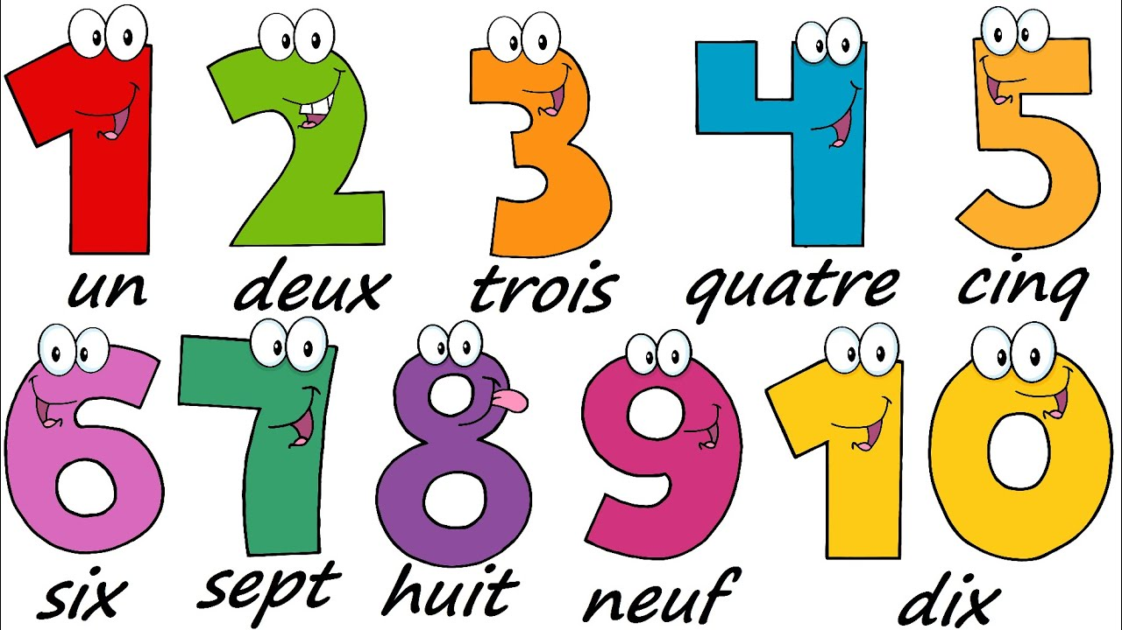

- Literacy
I can revise my ee and ai sounds again and try to use my learning to make words.
- Click onto https://www.youtube.com/watch?v=jFUz6cZAXNo
- Click onto https://www.youtube.com/watch?v=K-vehzhMSEg
- Click onto https://www.twinkl.co.uk/resource/ee-sound-break-and-make-activity-sheet-t-l-9128
- You don’t need to print this out but you can write out the words on a piece of paper
- Use your sound box to sound out the words as you make them

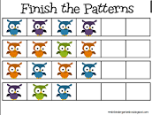

Practical Maths
I can learn about shapes and patterns and understand how to complete the sequence.
- Click onto https://www.topmarks.co.uk/ordering-and-sequencing/shape-patterns
- Try Levels 1, 2 and 3 to complete the patterns
- Can you try to make and colour your own pattern sequence using shapes or pictures?
Music
I can participate actively in songs, rhymes and stories.
- Click onto https://www.youtube.com/watch?v=aiMsd_KLugk to join in with the action song I am the Music Man
- Try the actions as you sing!

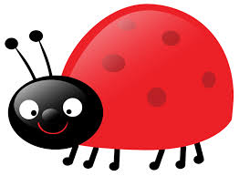
Story Time
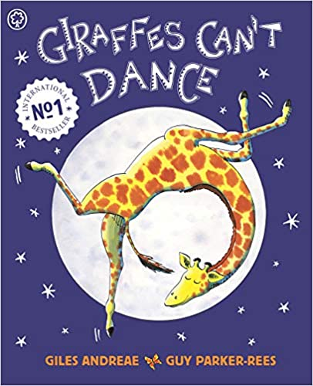
- Click onto https://www.youtube.com/watch?v=vZjsLK5vwNU to enjoy the story and animation movie called Giraffes Can’t Dance by Giles Andrea and Guy Parker

