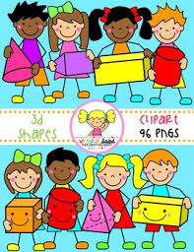
Primary 2 Home Learning Work From Miss Hall
Week 5 Thursday 7th May 2020
Hello Primary 2, here are some activities for you to try today.
To access the Twinkl documents you first have to sign up for a free membership account:
- Go to www.twinkl.co.uk/offer
- Sign up for a free account (entering parent as occupation)
- Enter the offer code UKTWINKLEHELPS

Practical Maths
Learning Intention – I can explore and learn about the idea of symmetry in pictures, patterns and shapes.
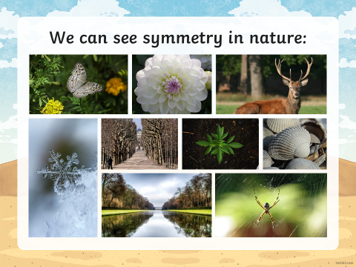
- Click on the website https://www.bbc.co.uk/bitesize/clips/ztpyr82 to listen to some ideas about symmetry

- Look at the Symmetry in Nature picture above and chat about what you notice
- Click onto https://www.twinkl.co.uk/resource/t2-m-284-line-of-symmetry
- You don’t need to print the sheet but look at each picture and decide if it has a line of symmetry down the middle
- Use a two sided mirror to do this if you have one but if not, use your learning to work this out please
- Do you see any objects around your home which have a symmetrical shape? Can you find 5 and explain what makes them symmetrical?
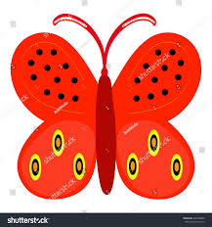
- Make your own symmetry picture from different small objects you can find at home or in the garden? Use your imagination and have fun!
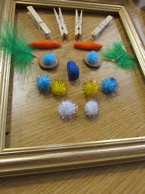
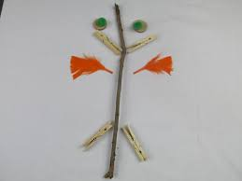

Literacy
Learning Intention – I can revise some of my Tricky Words and learn to say and write them in different ways.
picture letter better earth through always country young example paper those together
Literacy Continued
- Read each of the words, clap the syllables, use your sound box to sound out the words
- Read each of the words once more then touch your toes as you say each word
- Choose 4 of the words and write them carefully into your jotter

Learning Intention – I can learn to understand and recognise what a verb is and why we use these in our sentences.
Finding Out About Using Verbs
- Select the website https://www.bbc.co.uk/bitesize/topics/zrqqtfr/articles/zpxhdxs
- Click onto What is a Verb? and listen to the clip, then read the information below this
- Now try the next clip called Highlight the Verb and The Verbs Quiz
- Think about words which you think are VERBS and choose 3 to write into your jotter
- Choose one of them and use it in a super sentence to write into your jotter too

Story Time
Learning Intention - I can listen to the story, make predictions and learn new vocabulary.
- Click on https://www.youtube.com/watch?v=hycPZ2jtmhQ to listen to the funny story called Aliens Love Underpants by Claire Freedman
Music
Learning Intention – I can participate and enjoy singing and performing to the music
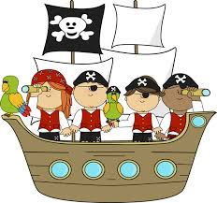
- Click onto https://www.youtube.com/watch?v=QVfVIcW1alo to listen and join in with The Pirate Song (When I was One)
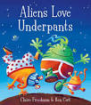

Art
Learning Intention – I can follow instructions and use this knowledge to create my own special art work related to my Seaside topic.
- Select the website https://buggyandbuddy.com/ocean-crafts-kids/
- Scroll down till you find the title Paper Plate Ocean Craft for Kids then look through the choices you have
- You need a paper plate, a variety of different coloured paper, paints, crayons, ribbons and exciting bits and pieces to decorate your plate with
- Don’t worry if you don’t have all of this, just use what you have!
- Look at the pictures on this page to help you with your ideas and imagination
- Take a photo of your finished plate if you would like to do this
These pictures from the website might help you with your choice.
Have fun and enjoy!

