PE Home Learning Week: Wed 6 May – Pentathlon Training!
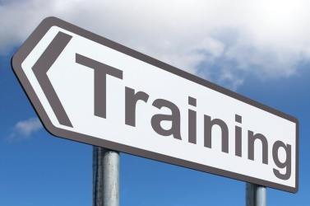
Focus Benchmarks:
Speed
Rhythm & Timing
Coordination & Fluency
Motivation

Learning Intentions:
UNDERSTAND what the word Pentathlon means?
BE ABLE TO take part in different athletic ‘Field’ events and improve your score
BE ABLE TO record your scores to complete a Pentathlon over the next 3 weeks

Task 1:

Watch the following video to understand the different activities you are going to be taking part in;

https://www.youtube.com/watch?v=o0PH0Z88SMs&list=PL6DK6xTdLkmwBkVBUkZZ2L_oTT6VXErNO&index=1

Task 2:
Take part in the following Events making sure you record your score on the table below.

You are going to be repeating these activities over the next weeks to try and improve your scores.
So make sure you are watching the resource videos to help you understanding how to set up and compete.
- Shuttle Run – keep this going, it’s so good for your fitness!
How fast can you run 5m distance 20 times?

Video resource: https://youtu.be/_JlpNSOp8x8
- Vertical Jump -How high can you jump?
Following the instructions on the video to see how to measure your jump.

Video Resource: https://youtu.be/20d_MA76CdQ

Task 4:
Record your score: It’s a short week!

Event | Week - 6 May | Week End 8 May | Did you improve?  Yes or No
Shuttle Run

Vertical Jump

How many events did you improve? Post any pictures into assignments. Go for it! Mrs Bell!

