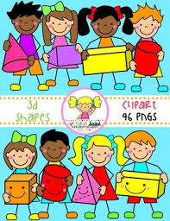Primary 1 Home Learning Work From Miss Hall

Week 5 Wed 6th May 2020

Hello Primary 1, here are some activities for you to try today.

To access the Twinkl documents you first have to sign up for a free membership account:

1. Go to [www.twinkl.co.uk/offer](http://www.twinkl.co.uk/offer)
2. Sign up for a free account (entering parent as occupation)
3. Enter the offer code UKTWINKLEHELPS

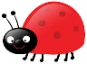Practical Maths

I can explore and learn about the idea of symmetry in pictures, patterns and shapes.

* Click on the website <https://www.bbc.co.uk/bitesize/clips/ztpyr82> **to look at some ideas about symmetry**
* **Click onto** [https://www.twinkl.co.uk/resource homelearninghub/t2-m-500-monster-symmetry-worksheets](https://www.twinkl.co.uk/resource%20homelearninghub/t2-m-500-monster-symmetry-worksheets)
* **You don’t need to print the sheet but choose 1 of the pictures to draw onto paper to complete the other half of the monster to make it symmetrical. Colour it too please.**
* **Do you see any objects around your home which have a symmetrical shape?**
* **Can you make your own symmetry picture from different small objects you can find at home or the garden?**
* **Take a photo and upload it to your Learner’s Journal if you would like to do this**

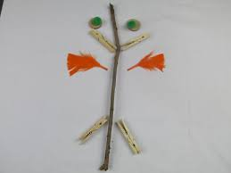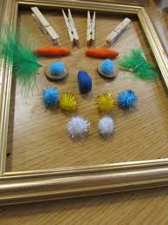

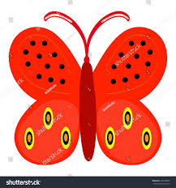

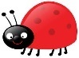Literacy

I can revise my Tricky Words from Block 2.

go we be she are they all some come said are they all

* Read each of the words once, then touch your toes as you say each word once more
* Choose any 3 of the Tricky Words then write them using one of these activities
* Rainbow writing with 3 colours, chalks or a squeezy bottle filled with water on your path outside
* Click on https://www.twinkl.co.uk Home Learning Hub/resource/t-s-190-uppercase-a-z-letter-formation-worksheets and choose Capital A only
* Use a coloured pen or pencil to follow the letter formation for each letter
* Now try this Flour, Salt, or Sand Writing. Choose the one you want to use.
* Write the letter A using your finger or a paintbrush. Put coloured paper under the flour/salt or sand to make the letter stand out
* Try this 3 times please on different plates

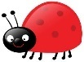Litracy

I can use my knowledge of sounds, letters and patterns to read words. I can revise the ee sound and the ai sound.

* Click onto <https://www.youtube.com/watch?v=jFUz6cZAXNo> **to listen to** **Phonics: The ee sound and use your sound box to help you say the words**
* **Play the game I spy with my little eye something that rhymes with ee. Look around your house to see anything with this sound**
* **Click onto** <https://www.youtube.com/watch?v=K-vehzhMSEg> **to listen to the Phonics ai Sound CVC words reading machine and use your sound box to say the words**
* **Play the game I spy with my little eye something that rhymes with ai. Look around your house or garden for words with this sound.**
* Can you make 2 ee words and 2 ai words outside using small pebbles, bark chippings, small leaves, chalks or other interesting things?

**ee ai ee ai ee ee ai ee ai ee ai ee ai ee**

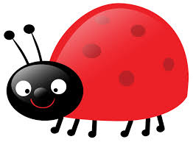

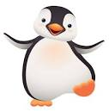Story and Music Time

 I can listen to the story, make predictions and learn new vocabulary.

I can participate and enjoy singing and performing to the music

* Enjoy listening to the story of Penguins Make Bad Pirates
* Click onto <https://www.youtube.com/watch?v=usMEVqz4CrU> **to enjoy the story**
* Click onto <https://www.youtube.com/watch?v=EBHtpU1tB3E> **to listen to the action song The Penguin Song/ Penguin Dance/Brain Breaks with Jack Hartman**

