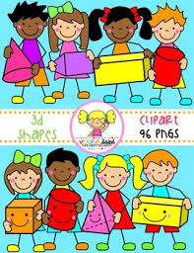
Primary 1 Home Learning Work From Miss Hall
Friday 1st May 2020
Hello Primary 1, here are some activities for you to try today.
French
I can learn how to say the different weathers we have in French.
- Click onto https://www.twinkl.co.uk/resource/t-t-6300-french-weather-poster and print this please
- Select https://www.twinkl.co.uk/resource/t-t-6298-french-weather-powerpoint and try to repeat the French weather words
- Click on https://www.twinkl.co.uk/resource/fr-t-t-9087-draw-the-weather-worksheet-french and use your learning to draw and colour the pictures
- Can you look outside and describe the weather you have just now in French? Chat to your family about it.
Literacy
I can revise my Tricky Words from Block 2.
go we be she are they all some come said one you
- Can you read this sentence and look for all the tricky words you can see?
- Write the sentence and put a ring around all the tricky words
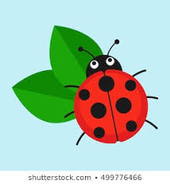
- Come and see all the ladybirds on this leaf in my garden said my Mum.
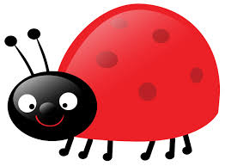

Music
I can participate actively in songs, rhymes and stories.
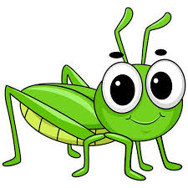
- Click onto https://www.bbc.co.uk/bitesize/clips/zhpr87h to join in with The Grasshopper Hop song
- Try to do the actions as you sing!

Story Time
- Click onto twinkl.co.uk/resource/the-Zoo-Vet-ebook-t-or-1115 to enjoy the story called The Zoo Vet
- Select https://www.twinkl.co.uk/resource/the-zoo-vet-what-am-i-animal-powerpoint-t-or-1114 to try this quiz about the story
Enjoy your holiday weekend everyone!

