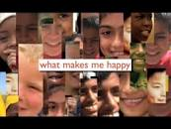
Looking at what makes you and others happy
Watch Ranjita’s story in the powerpoint. It is a good idea to make short notes in your jotter as you watch. Think about the differences between Ranjita’s life and your own. You can illustrate or write your answers (or a combination of both). Use the chart below and upload to P5 Teams or use a double page in your jotter.
THINGS YOU CAN COMPARE/CONTRAST AND DRAW/WRITE ABOUT: houses, tasks, roads, daily life etc Remember to tell what makes Ranjita and you happy. Can you see any of our Values in Ranjita’s ways of life?
Ranjita’s Life | Your Life

