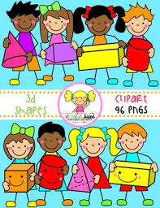
Primary 2 Home Learning Work From Miss Hall
Week 4 Thursday 30th April 2020
Hello Primary 2, I hope you and your family have enjoyed the sunshine recently. Here are some activities for you to try today.
Practical Maths
Learning Intention – I can learn about patterns and understand how they can be developed and created from a variety of different objects and materials.
- Click on the website www.twinkl.co.uk.t-t-7245-int to pattern powerpoint
- Click on the website www.twinkl.co.uk/resource/au-n-778-growingpatterns-lessonyear1-2powerpoint and chat about how the patterns develop
- Create your own patterns from lego, cubes or other small objects and use this website to help you with ideas – t-t-11551-lego-Pattern-Challenge-Cards
Literacy
Learning Intention – I can revise some of my spelling words and learn to say and write them in different ways. I can learn how to recognise nouns and how we use them.
paper those together cooking chewing boiling drawing joining crawling
- Read each of the words, clap the syllables, use your sound box and say them using different voices
- Choose 5 of the words and write them outside using either chalks or a paintbrush and water
- Select the website Twinkl.co.uk/t-l-4911-nouns-powerpoint people/places/things
- Enjoy this interactive wordsearch twinkl word-search-tg-246-newlink
Story Time
Learning Intention - I can listen to the story, make predictions and learn new vocabulary.
- Click on youtube.com/watch/v=p9GyGxpmpcM to enjoy the story The Bears Who Went to the Seaside by Susanna Gretz
Music
Learning Intention – I can participate and enjoy singing and performing to the music
- Click onto youtube.com/watch/v=KcltyyuGjuKo to listen to the song I Do Like to be Beside the Seaside
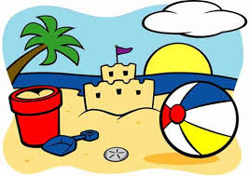
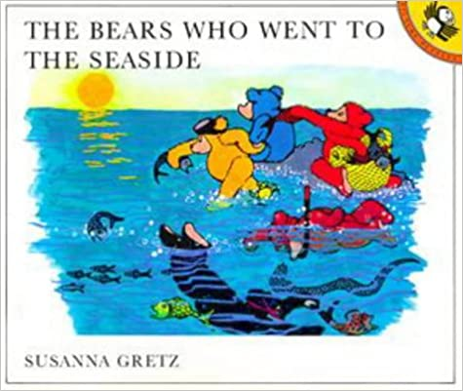
- Remember to create your own actions as you sing!

Art
Learning Intention – I can follow instructions and use this knowledge to create my own special art work related to my Seaside topic.
- Select the website https://buggyandbuddy.com/ocean-art-project-for-kids-using-watercolor-and-salt/
- Scroll down till you find the title ‘Ocean Art Project for Kids Using Oil Pastels, Watercolour and Salt’
- Please read and follow each instruction with someone in your family
- Use wax crayons or a candle if you don’t have oil pastel crayons to make the wave effects. You can use sea colours instead of white if you want. This will be fine.
- You can make your sea creatures with felt pens, chalks instead of paints
- Be inventive!
- Take a photo of your art work and upload it to your Learner’s Journal if you can
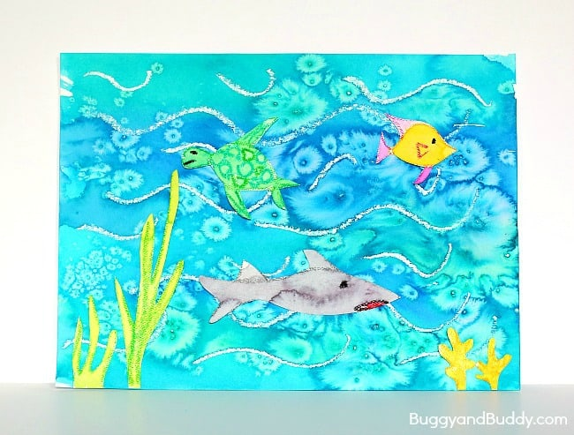
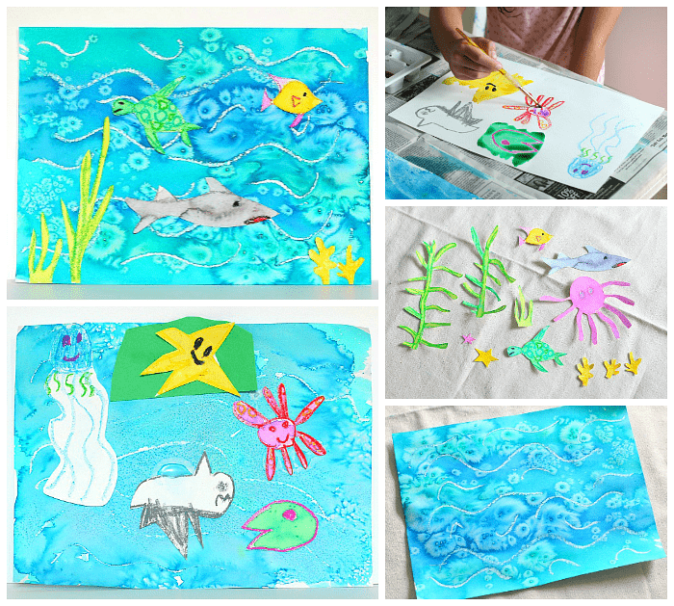
- Enjoy yourself and have fun!

