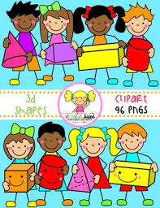
Primary 1 Home Learning Work From Miss Hall
Week 4 Wed 29th April 2020
Hello Primary 1, I hope you are well and enjoying the lovely sunshine we have had. Here are some activities for you to try today.
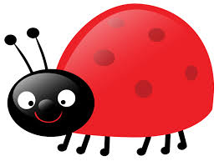
Practical Maths
I can learn about money and find out what different coins are worth.
- Try this coin ordering cut and paste activity sheet – Twinkl.co.uk/resource/t2-m-2290
- Click onto this quiz powerpoint Twinkl T-N-1278-How Much Money is in My PiggyBank? to play the game
- Use a variety of real coins and do some coin rubbings with them
- Place the coin underneath a piece of paper and use crayons or pencils to rub over it. You can make a collection of them to create a pattern.
Literacy
I can revise my Tricky Words from Block 2.
go we be she are they all some come said one you
- Can you say this sentence then write it in your jotter? Now use a coloured pen to put a ring around the Tricky Words you can spot.
- You can see that all the squirrels are having lots of fun in the garden said my Mum.
I can use knowledge of sounds, letters and patterns to read words. I can learn about the long ee sound.
- Click on youtube.com/watch?v=jFUz6cZAXNo – Phonics The ee sound
- Now watch Geraldine the Giraffe learns /ee/sounds – youtube.com/watch?=qfM7Hz7USOU
- Make 3 easy ee words outside using small pebbles, bark chippings, small leaves or any other interesting materials
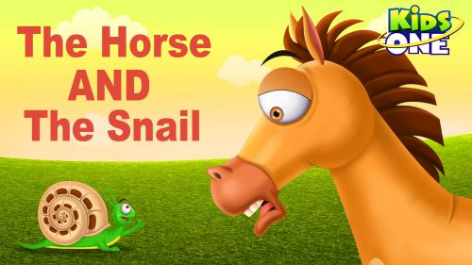
- Take a photo and upload it to your learner’s journal if you can
Story Time
- Enjoy listening to the story of The Horse and the Snail
- Click onto youtube.com/watch?v=QurK2Wm4mJ8
- Have some fun with this sounds game
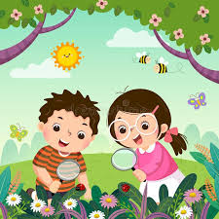
- Select twinkl.co.uk?go/resource/tg-ga-146-level1-phonics The Garden Environmental sound game

