Active Spelling Activities

Flour/Salt/Sand Writing

Spell words using finger or paintbrush. Put coloured paper under the flour, salt or sand to make the letters stand out.



Toy Words

Use jigsaw pieces, small cars or Lego pieces to make words from your list.

Rainbow Words

Use chalk to write your spelling words outside. Take a photo.

Stone Words

Make spelling words from stones.

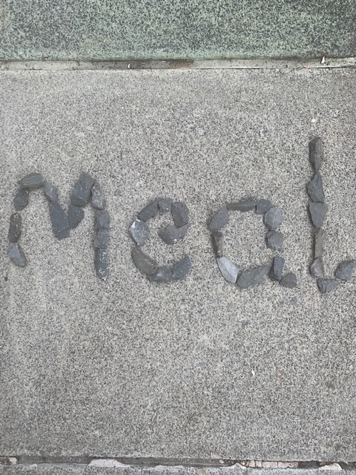

Icing Sugar Words

 

Paint Sounds

Use your finger or a paintbrush to paint your spelling words. Paint a picture to match.

Playdough Fun

Make long sausage shapes into words, if possible they should use the correct formation and trace it with your finger.