Please share your working in the assignments area.
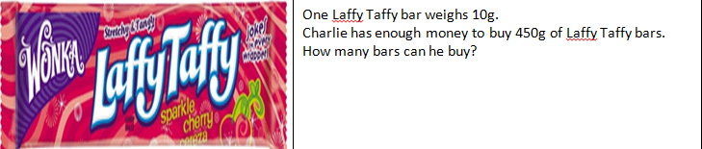
Can you help Willy Wonka solve some problems in his factory?

