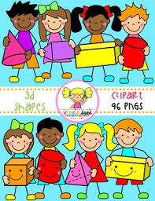
Primary 1 Home Learning Work From Miss Hall
Friday 24th April 2020
Hello Primary 1, here are some activities for you to try today.
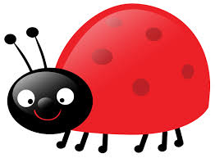
Practical Maths
I can learn about the Days of the Week.
- Click on YouTube to listen to The Singing Walrus Days of the Week Song
- Select this site to play games related to What Are The Days Of The Week? https://www.bbc.co.uk/bitesize/topics/zrqqtfr/articles/ztjg39q
- Use a calendar for 2020 to find out the day of the week for your birthday and some of your family and write down 2 of them in your jotter
Literacy
I can revise my Tricky Words from Block 2.
go we be she are they all some come said are they all
- Write 2 super sentences neatly in your jotter using your own choice of Tricky Words.
- Click on twinkl.co.uk phase 2 Rhyming Words powerpoint t-l-527505 to play a game with 3 letter cvc words
- Select twinkl.co.uk/resource/t-l-526945 sorting sounds powerpoint game to revise some sounds
Music
I can participate actively in songs, rhymes and stories.
- Click on Youtube.com/watch?v= OK08DaPLyX0 – Simon Says Song for Children by Patty Shukla and join in with the actions please

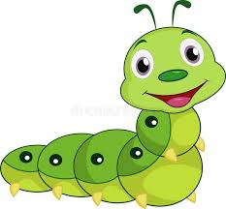
Story Time
- Click onto YouTube.com/watch?v=UG-Q2ZL3w-Y to listen and share the story about The Cautious Caterpillar
- Chat about your favourite part of the story and make a colourful picture using pens, crayons and any other sticky things you can add

Have a lovely weekend Primary 1 and enjoy this lovely sunny weather!

