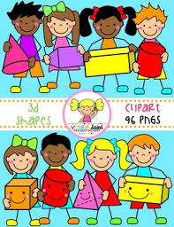
Primary 2 Home Learning Work From Miss Hall
Week 3 Thursday 23rd April 2020
Hello Primary 2, I hope you and your family are all well and you enjoyed your Easter break. Here are some activities for you to try today.
Practical Maths
Learning Intention – I can revise 3D shapes and learn to recognise them and discover their names.
- Click on the website www.twinklhomelearning3Dshapespowerpointearlyyears
- Click onto 3D ShapesInteractive Powerpoint – Maths Resource
- Select each picture and name the 3D shapes
- Click on the site www.bbc.co.uk.bitesize.clips and select The 3D Shape Song KS1 and join in
- Try a Shape Hunt in your home or garden and make a list of objects you may find which are similar to 3D shapes
Literacy
Learning Intention – I can revise some of my spelling words and learn to say and write them in different ways.
floating throwing toasting counting coaching shouting
- Read each of the words and say them using different actions
- Choose 4 of the words and write them out using colourful Rainbow Writing with 4 colours for each word
- Select the website Twinkl.co.uk-t-t-5653 Seaside-Video-Powerpoint to chat about what you notice
- How many ing words can you use to describe the sea, creatures and birds in the video?
- Use your 5 senses to help you and write down some of these ing words as you watch it
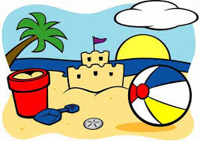
- Enjoy this seaside labelling game by clicking on twinkl.co.uk/seaside-interactive-tg-325-newlink

Music
Learning Intention - I can participate actively in songs and enjoy the music.
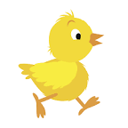
- Click on Youtube.com/watch?v=Eey4LZLeGw – I’m a Spring Chicken and remember to do the actions
French
I can learn about French Greetings by listening to songs and use my learning to interact with my family to share my learning.
- Select YouTube.com/watch –v=NXKJ88ygPYO to watch the video French Greeting Songs for Children
- Can you use the French Greetings to ask your family their names?
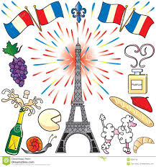
- Try some of the other French Greetings with them

