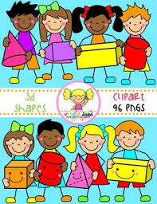
Primary 1 Home Learning Work From Miss Hall
Week 3 Wed 22nd April 2020
Hello Primary 1, I hope you and your family are all keeping well and you enjoyed your Easter break. Here are some activities for you to try today.
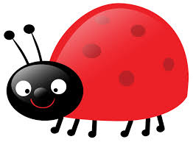
Practical Maths
I can learn about the 4 Seasons of the Year and revise the Days of the Week.
- Click on YouTube to listen to The Singing Walrus Days of the Week Song
- Click on the Twinkl website to select the Days of the Week Cut and Stick sheet
- Click on Twinkl.co.uk//resource/t-tp-5463-4 Seasons Display Signs and chat about what you notice in the pictures
- Try this quiz to see if you can work out the seasons from this powerpoint
- Click on twinkl.co.uk/resource/t-tp-1043T What Season am I? to select this
Literacy
I can revise my Tricky Words from Block 2.
go we be she are they all some come said are they all
- Read each of the words and say them using different actions
- Can you write a sentence in your jotter using 2 of these tricky words?
- Use chalks or a squeezy bottle filled with water to make 5 of the words on your path outside if you family allow you. If not, please use coloured crayons and paper to write the words.
Music
I can participate actively in songs.
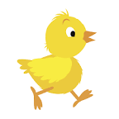
- Click on Youtube.com/watch?v=Eey4LZLeGw – I’m a Spring Chicken and remember to do the actions!

French
I can learn about French Greetings by listening to songs.
- Select YouTube.com/watch –v=NXKJ88ygPYO to watch the video French Greeting Songs for Children
- Can you use the French Greetings to ask your family their names?
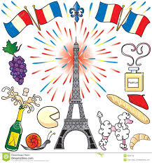
- Try some of the other French Greetings with them

