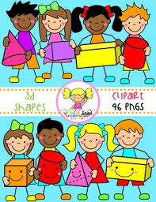
Primary 1 Home Learning Work From Miss Hall
Week 2 - Wednesday 1st April 2020
Hello Primary 1, I hope everyone is keeping well. Here are some activities for you to try today. There is no time limit to finish them as you can continue another day.
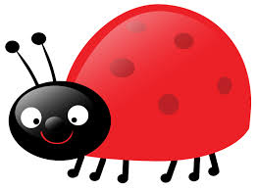
Practical Maths
Learning Intention – I can revise 3D shapes and learn to recognise them and discover their names.
- Click on the website www.twinklhomelearning3Dshapespowerpointearlyyears
- Click onto 3D ShapesInteractive Powerpoint – Maths Resource
- Select each picture and name the 3D shapes
- Click on the site www.bbc.co.uk.bitesize.clips and select The 3D Shape Song KS1 and join in
- Try a Shape Hunt in your home or garden and make a list of the 3Dobjects you may find
Literacy
Learning Intention – I can revise some of my green tricky words and learn to say and write them in different ways.
go be she are they all some come said one you
- Read each of the words and say them using different funny voices
- Choose 5 of the words and write them in larger letters using different methods
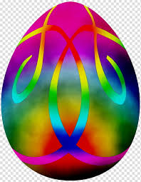
- Use rainbow writing with 5 different colours, bubble writing using 2 bright colours and think of your own fun ways to do this too
Art and Craft – Easter Celebrations
- Use the website www.homelearningeasterphotoclipartpack
- Use an A4 piece of paper to draw your own large egg shape
- Decorate your egg with crayons, glitter, finger painting and any other colourful items
- Cut it out and stick it on a colourful background and enjoy!

