Literacy and English  Comprehension - Watch the trailer for Finding Nemo  https://www.youtube.com/watch?v=wZdpNglLbt8  discuss these questions with an grown up.  Why was Nemo’s Dad upset?  How many different sea creatures did you spot?  Do you think Nemo was in danger? Why?  Does the trailer make you want to watch the film? Why? | Numeracy and Mathematics  Shape 2D and 3D  Play ‘Guess the shape’. Describe a shape, remembering to say how many sides and corners. Can you spot any 2D and 3D shapes around you? What places, animals or objects can you draw using only 2D shapes? | Health and Wellbeing  Friendship - Nemo had lots of friends who looked out for him. Draw a picture of all of your friends and talk about the other people in your back up team.  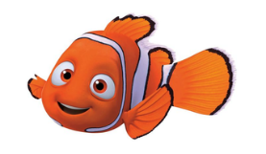
Literacy and English  Diagram - Draw a picture of a fish and label its parts  tail fin head gills  eyes mouth  Can you find out any other facts about fish? | Numeracy and Mathematics  Practice counting forwards and backwards to 20 stopping and starting at different points.  Practice the number before and the number after.  https://www.topmarks.co.uk/ordering-and-sequencing/caterpillar-ordering | STEM  Floating and Sinking – ask an adult to help you fill a basin or bowl with water. Find items around the house and test to see if they float or sink. Make a guess first before you try. This is called an estimate. Were there any surprises?
Literacy and English  Word-building -How many words can you make with these letters? Use magnetic letters, foam letters or cards with the letter on.  t a p r i s n e m  map pan sip | Numeracy and Mathematics  Spotting Numbers – Have a look inside and outside and see how many numbers you can spot. How many numbers you can say? How many can you write?  1 2 3 4 5 6 7 8 9 10 | Expressive Arts  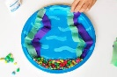  Design some plants and animals that you would find under the sea, Cut them out and stick them in a bowl, paper plate or a jar as a home for a fish. Design and make a fish to live in it.  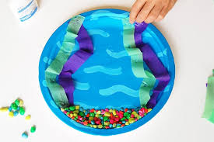
Literacy and English  Sentences  Think of a sentence that contains the words…  pin, sat, nip, nap, pan, pat. Say the sentence out loud. Can you make a funny story using some of these words? Eg I sat on the beach and a crab decided to nip my toes. | Numeracy and Mathematics  Length -  Collect as many objects as you can that are longer than your thumb.  Collect as many objects that are shorter than your sock.  Which item is the longest? Which is the shortest? | Social Studies  Keeping Safe on the road – practice with an adult the rules for crossing the road safely. Remember to  Stop, Think, Look, Listen!
Literacy and English  Reading - Choose your favourite story and ask a grown up to read it to you. Can you find any tricky words you know? Draw a picture of your favourite character and talk about what you like about them. | 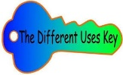  Problem Solving  Different Uses Thinking Key  How many different uses can you think of for a goldfish bowl? | Health and Wellbeing  Scavenger Hunt – Go outside for a walk or to the park and try and collect these items:  Pine cone, white stone, black stone, bark, fallen apple, piece of wood, fallen leaves, twig, acorn, sycamore key
