Literacy and English - Reading  Select and read, or listen to, a story of your choosing. Explain why you chose this story. What did you like/dislike about it?  Were you able to give your own opinion on the story? | Numeracy and Mathematics – Number Hunt  Find numbers in newspapers, junk mail, around your house etc. Cut them out and make a poster, show them to your family or take photos of them.  Challenge: Can you find 2 numbers the same? What is the largest/smallest number you have found? Challenge someone to find a larger number. | Health and Wellbeing  Can you create a repeating action pattern? Practise the pattern below then make up your own to get your heart beating faster:  clap clap, stomp stomp, clap clap, stomp stomp  jump jump jump, wiggle, jump jump jump, wiggle
Literacy and English - Vocabulary and Spelling  Use the words your teacher has given you (or pick some words from the book you are reading). Play spelling tennis with a partner. You say one letter and your partner says the next until the work is complete. Choose some other words to play this with. They might be connected to a topic you are covering. | Numeracy and Mathematics - Sequencing  Sequence numbers in the range 1-30 eg write 14, 15, 16, 17 on separate pieces of paper, mix them up and sequence them. Repeat for other sequences.  Challenge: Try to sequence larger numbers? Can you order numbers found on the Number Hunt? | STEM  Blast off to space. Watch how the Earth looks from space, what do you see?  https://www.youtube.com/watch?v=EEIk7gwjgIM  Think about what you know about space and find out something new.
Literacy and English - Writing Techniques  Write as many sentences as you can think of using these 3 words:- dog shoe river  Check that your sentences:-  - have capital letters, full stops and spaces  - make sense | Numeracy and Mathematics – Recognising Numbers  Point to a number between 1 and 30. Ask “what number is this?” Possible contexts – door numbers,  pages in a book, buses.  Challenge: Look at two of your numbers. Which is larger? Also ask for the number before or after. | Expressive Arts  Go outside with paper or a notebook, find a place to sit either in your garden or by a window and sketch the landscape you see. Are there buildings or trees? Try to focus on and draw only what you can see.
Literacy and English - Extended Writing  I am learning to write a clear sequence of events.  Choose one of the pictures from attached sheet. What do you think might be happening? Write at least 3 sentences to tell the story. | Numeracy and Mathematics – Dot to Dot  Complete the dot-to-dot puzzle on the back of this sheet.  Challenge: Can you do it backwards (starting from the largest number)? | Social Studies  How can you care for your community? You could:  -make a sign to remind people in your house to wash their hands  -pick up litter with an adult in your local area  -tidy your things to make a donation to charity
Literacy and English - Listening and Talking  Choose a household item or one of your toys. Think of 3 interesting facts about that object and note them down. Can you talk about your object for 1 minute? Did you speak loud enough to be heard and slow enough to be understood? | Puzzle  Try to find two objects at home that are the same height or length. Try to find two that feel the same weight. Can you find 3? | Health and Wellbeing  Make a fruit salad with at least three types of fruit. How many different colours and shapes can you include? How about juice or tinned fruit?

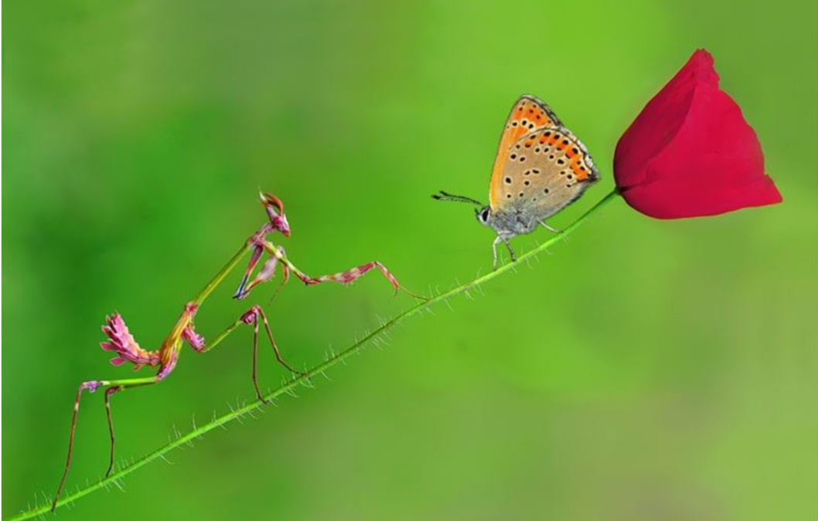

Think about:-
Who is in the picture?
Where are they?
What are they doing?
What do you think they are saying to each other?
What might happen next?
Remember to:-
- Use capital letters and full stops.
- Leave spaces between your words.
- Read your sentences to make sure they make sense
Extra challenge
See if you can get ‘and’ or ‘but’ into one of your sentences.

Write your story here.

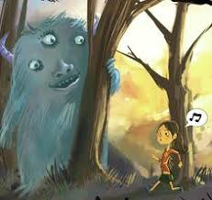
Remember to:-
- Use capital letters and full stops.
- Leave spaces between your words.
- Read your sentences to make sure they make sense
Extra challenge
See if you can get ‘and’ or ‘but’ into one of your sentences.
Think about:-
Who is in the picture?
Where are they?
What are they doing?
What do you think they are saying to each other?
What might happen next?

