Literacy and English  Read for 25 minutes each day.  Choose one quote per day from your book/text that you like. Explain to a family member or write down why you like it and why it makes the story interesting. | Numeracy and Mathematics - Counting Out Loud  Choose one of the following times tables – 2, 3, 4, 5, 6, 7, 8, 9, 10. Count forwards up the times table e.g. 2, 4, 6, 8, 10, … and then backwards to get back to where you started. Challenge: How quickly can you complete each times table? Try to beat your best time. Challenge people in your family to a race. | Health and Wellbeing  Plan a 30 minutes daily fitness timetable that you can do every day this week. It can be the same exercise activity every day or a different one each day.
Literacy and English – Be a Film Critic  Think of a film you have recently watched and enjoyed. Complete a film review for this movie in the style of a film critic. Use the attached sheet to complete your review. | Numeracy and Mathematics - Making Numbers  Roll a dice 3 times. Write down a number you can make. How many different numbers can you make? What is the largest possible number? What is the smallest?  Challenge: Can you predict how many numbers you can make from 3 digits? Will it be fewer if 2 or 3 of the numbers you roll are the same? | STEM  Create a Stop-Motion Animation. You could focus on lockdown or think big and imagine what life would be like on a different planet! The link below gives great tips on equipment and how to get started:  https://tinkerlab.com/easy-stop-motion-animation-kids/
Literacy and English –  Make a quiz about your favourite movie or book character. Compose at least 10 questions. You can write it down or make it here…  https://www.quiz-maker.com/ | Numeracy and Mathematics – Big Numbers  Write down a number with up to 6 digits e.g. 74302. Can you say your number (e.g. seventy-four thousand, three hundred and two)? What is the number after and number before your number? Once you have done 5, order your numbers from smallest to largest.  Challenge: Say your number to a family member and get them to write down what they hear. Did they write your number correctly? Now swap and get them to say their number to you. | Expressive Arts  Look at the attached sheet and have a go at designing your own set of geometric and doodle patterns “Zentangles”. There are also YouTube clips you can watch which demonstrate different techniques.  https://www.youtube.com/watch?v=s8PpYI3cPbE
Literacy and English  Game Instructions - Design a set of clear instructions that teach people how to play your favourite game. Before you write, make notes while playing the game (if possible) so you don’t miss out key info. Use the Game Instructions sheet to help organise your writing. | Numeracy and Mathematics – Telling the Time  Look for the time in lots of places e.g. phone, TV, clock. Write the times that you see in 12-hour and 24-hour time.  Challenge: Can you work out how long it is from one time that you record to the next? | Social Studies  What’s your opinion? COVID-19 has had a negative impact on many areas of our lives. Consider the ones we have suggested on the attached sheet. Pick one area and ask your family what they think could be done to improve this. Record their opinions and your own on the sheet.
Literacy and English  What is the difference between direct and indirect speech? How do we report what characters say in a variety of ways? Complete the attached worksheet to practise and apply this skill. | Puzzle - Dance Time!  A dance teacher has 6 dancers in his group and he wants each dancer to dance with each other dancer  once. How many dances will he need altogether? How many different couples will there be altogether?  (HINT: Name your dancers A, B, C, D, E and F. Write out all the combinations) | Health and Wellbeing  Create your own ‘home school’ timetable –decide which activities to do each day and when. Include non-school activities such as lunch, TV time, board games and chill time.

Genre and style of film
Who would enjoy this film?

What was the film production like? E.g. costumes, music, soundtrack, special effects, locations
Which character did I like the best and why?
Main Characters and who stars in these roles?

Setting of film (place and time)
Star rating
Summary of Plot

Title

Game Instructions

Name of Game: ____________________________________________

Aim of Game: ______________________________________________

______________________________________________

______________________________________________

______________________________________________

Number of players required:

__________________________________

How to play: (use numbers or bullet points to organise your writing. Include sentence starters like First, Next, Players, Carefully, Look out, Make sure….)
_______________________________________________________________________________________________

_______________________________________________________________________________________________

_______________________________________________________________________________________________

_______________________________________________________________________________________________

_______________________________________________________________________________________________

_______________________________________________________________________________________________

_______________________________________________________________________________________________

_______________________________________________________________________________________________

_______________________________________________________________________________________________

_______________________________________________________________________________________________

Direct to Indirect Speech.
We can report what somebody says without needing to use speech marks. For example,
“I want to be a hero!” announced Ruskin.
becomes
Ruskin announced that he wanted to be a hero.

Notice these things:
1. You have to write reported speech in the past tense.
2. The word that is important.
“I like your tie!” commented Hamza.
Hamza commented that he liked my tie.

Change these examples of direct speech into reported speech.
1. “This work is easy!” exclaimed Zia.
2. “I want to go home,” pleaded Mr Staiger.
3. “It’s playtime,” announced Ms Foley.
4. “I know the answers,” Samantha whispered to Alisha.
5. “I want children to feel calm,” said the kind teacher.
6. “I’m too tired to carry on,” complained Andrew.
Now create some of your own. Look in a book you have read or are reading. Can you find some direct speech? Turn 3 direct speech examples into reported speech.

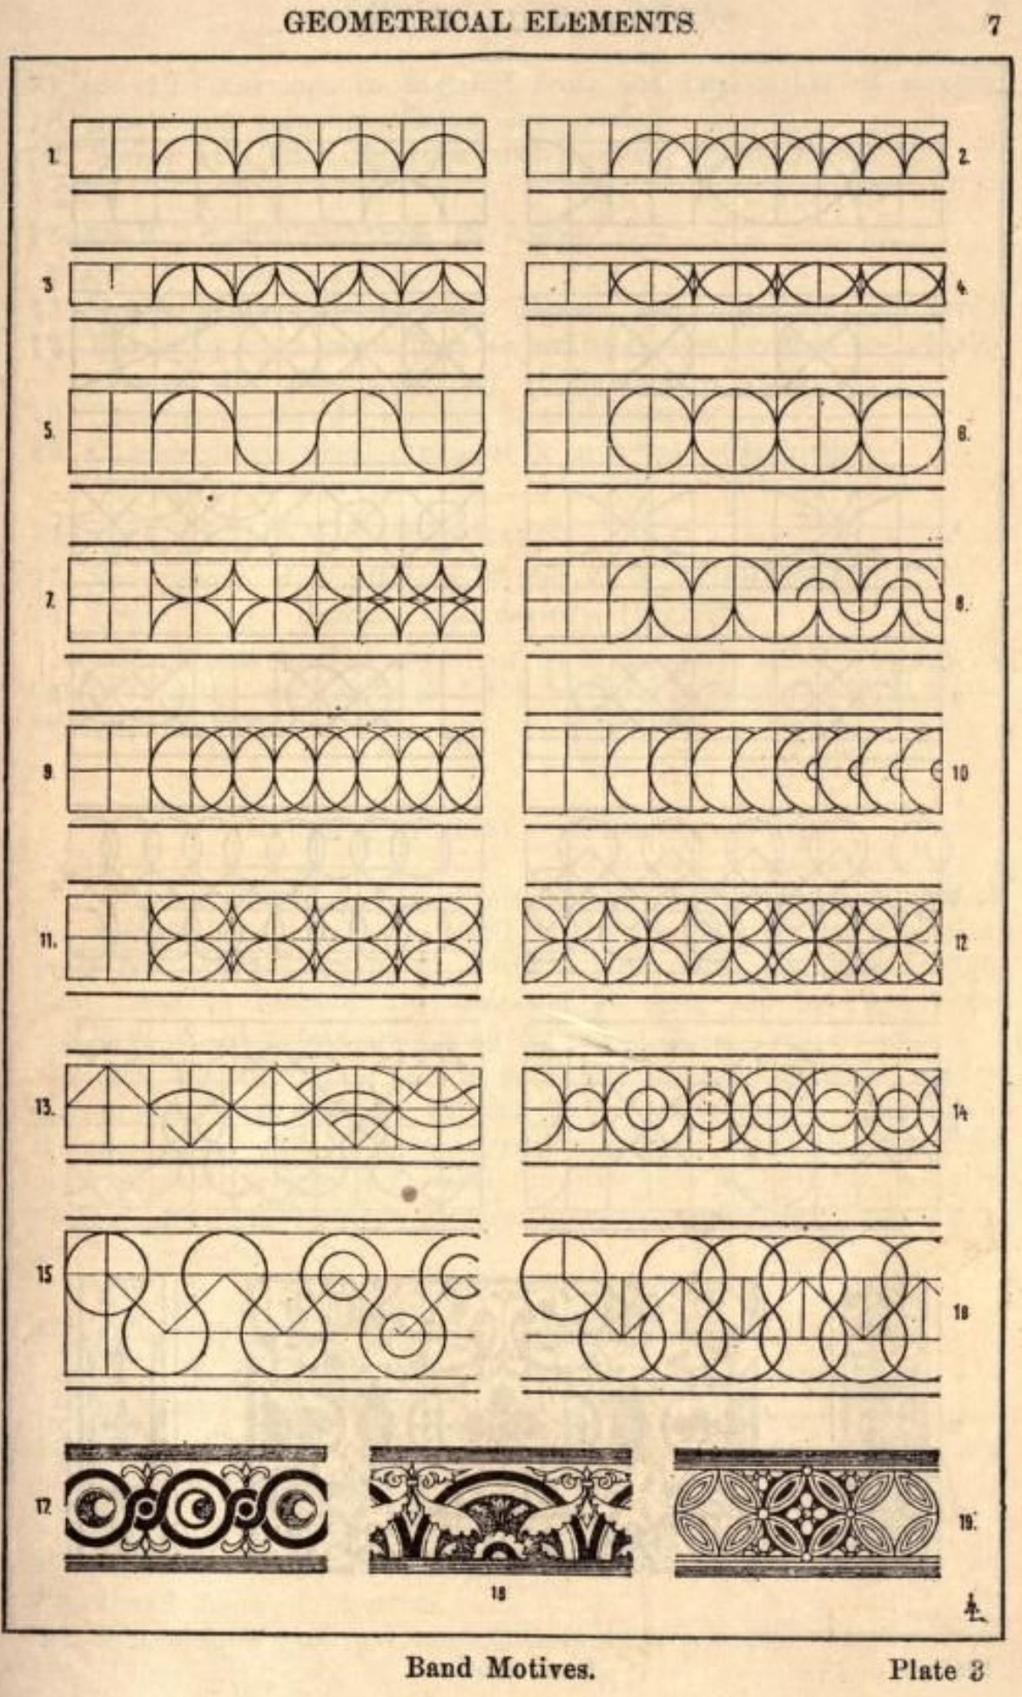

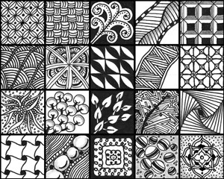

Social Studies – What do you think?

- How has the closure of city centre offices and large numbers of staff working from home affected Cafes and small business in the centre of towns?

- How has the need for social distancing impacted restaurants, hotels and leisure centres?

- Which areas of our lives have had to change significantly due to the cancellation of large gatherings and guidance on maximum numbers of people being together at one time?

- What has been the impact on people who attend places of worship as part of their religious beliefs and faith?

Choose one of the questions and consider your own thoughts? Ask the people that you live with what they think and record their statements below.

