MAKE IT!  A toilet roll anemone.  Paint your toilet roll tube purple and add some pink paper round the top for the tentacles.  Don’t forget to add some eyes. | MAKE IT!  A toilet roll bristleworm.  Paint your toilet roll tube yellow.  Stick on some little bit of paper to make the bristle.  Add some eyes. | MAKE IT!  Handprint hermit crab.  Do two red handprints together to make a crab shape.  Add some eyes.  Now draw a shell out of a piece of card.  Maybe you could make lots of different shells for your crab to try out.
WATCH IT!  Learn about symbiosis in this episode of Octonauts.  The Crab and the sea urchin.  https://www.youtube.com/watch?v=hT_aNzQcadY | Learning Grid  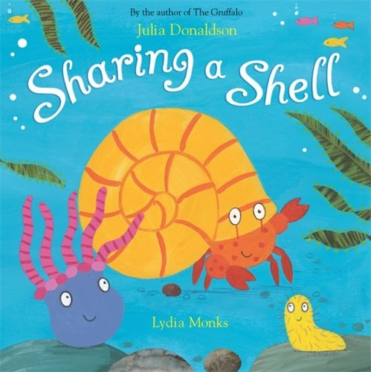  P1 Transition | READ IT!  Listen to the story online.  https://www.youtube.com/watch?v=l42fh58uGoY
COLOUR IT!  Look at the character sheet. Colour them in to match the characters in the book. Now cut them out to make little story puppets. |  | WRITE IT!  Practice your writing using the pattern sheets.
COUNT IT!  Can you count all the different creatures on the sheet?  How many of each creature are there? | SING IT!  Sharing a shell song.  https://www.youtube.com/watch?v=YxbYzI4_DDg | SAY IT!  Can you try this tongue twister sentence?  She sells seas shells on the seashore.

