Make your own octopus

You will need:
- Toilet paper rolls
- Scissors
- A pen
- Paint
- Paint brush
- Optional googly eyes, sequins

Step 1:
- Use the scissors to cut lines up to almost half way through the toilet paper to make 8 legs.
Step 2:
- Use the pen to curl the ends of the legs to make it look more realistic.
Step 3:
- Pain the octopus whatever colour you want.
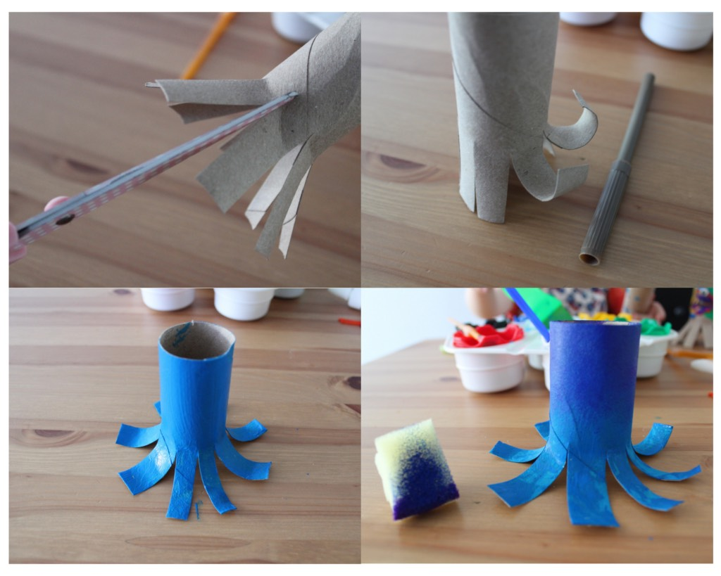
Step 4:
- Once dry you can either add googly eyes or paint your own ones on.

