Reading
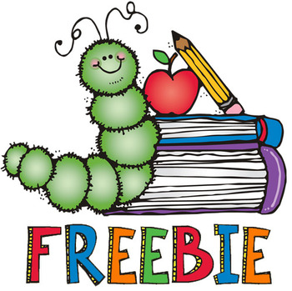
Reading is important for children’s development. This is a guide for Reading at home just now.
- Children should read their book 3 times a week. Adults should support the children. Also ask them questions on their understanding of the book.
- Each week complete at least one activity. The online books come with different activities. Some are on the front and back pages of the book and some have activities (tabs above) on the computer.
Reading question ideas (Can be discussed with children with any book whether a bedtime story or reading books)
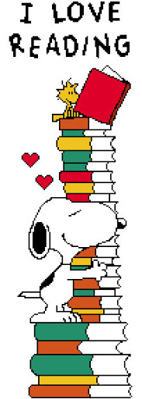
- What characters are in the story?
- What is the story about?
- What type of text are you reading?
- Retell the story using the key points.
- Who is telling the story?
- Is this fiction or non-fiction?
- Why are you reading the story?
- Where is the story set?
- Who is your least favourite character? Why?
- Who is your favourite character? Why?
- How did the story make you feel at the end?
- What would the main character do if they visited your classroom/house?
- Describe what is happening in the first picture of the book?
- Can you think of a different ending to the story?
- I can relate to this book because…
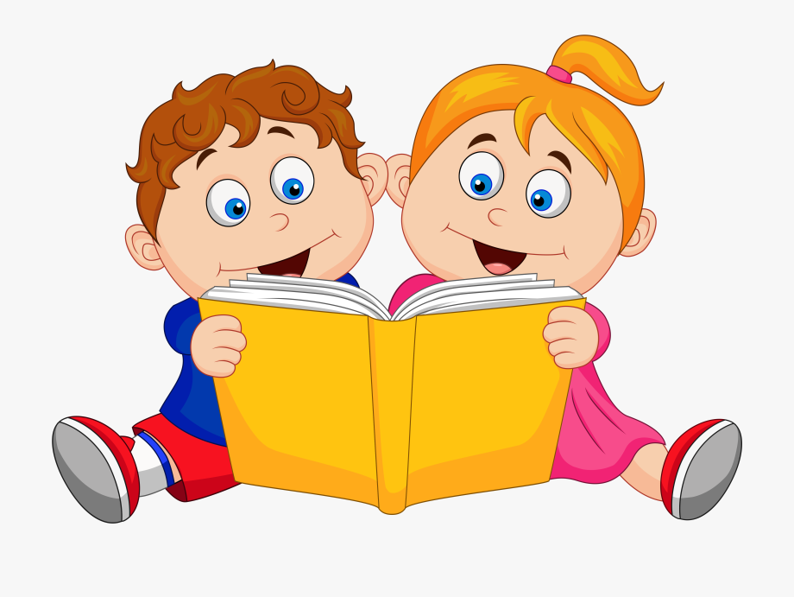

Writing/making activities
- List 2 new words you learned in the book.
- List 3 new words you learned in the book.
- List 5 new words you learned in the book.
- Can you make a story map of the book?
- Can you write a blurb for the book?
- Can you write a review of the story?
- Find the rhyming words and think of other words that would rhyme.
- Look for tricky words.
- Make a new character to join the story? Draw it?

