C:\Documents and Settings\laura.gingell.SCHOOLS\Local Settings\Temporary Internet Files\Content.IE5\7GL6QQJA\MC900234428[1].WMFC:\Documents and Settings\laura.gingell.SCHOOLS\Local Settings\Temporary Internet Files\Content.IE5\7GL6QQJA\MC900198994[1].WMF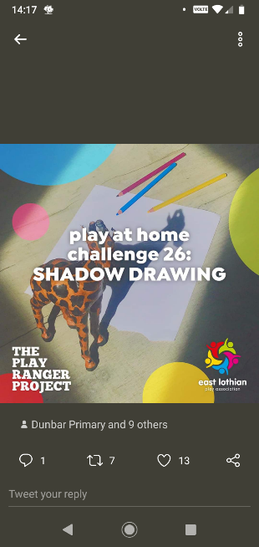C:\Documents and Settings\laura.gingell.SCHOOLS\Local Settings\Temporary Internet Files\Content.IE5\7GL6QQJA\MC900094743[1].WMF

PE!

If you can, go onto YouTube for a Just Dance routine (try <https://www.youtube.com/watch?v=Jf_dEcgeJWo>) or a Cosmic Yoga story (try <https://www.youtube.com/watch?v=T_0P5grVoyg>)

Or join in with the daily Joe Wicks routine - <https://www.youtube.com/channel/UCAxW1XT0iEJo0TYlRfn6rYQ>

If you can’t go online, put on some music or listen to the radio and make up a dance to your favourite tune!

**Challenge Time**

**Shadow Drawing**

**Find an object that has a shape you like. Set it up so that it casts a shadow on paper – you can use the sun or an inside light.**

**Draw round the shadow and decorate it!**

NUMERACY!

SHAPES

How many different shapes can you count on the Shape worksheet?

Can you name any of them?

If you can print the sheet, you can colour it in. Or you could draw your own shape picture, of a garden or anything else.

What shapes can you spot in your house or garden?

Try making some shapes online – can you make a picture?

<https://www.coolmath4kids.com/manipulatives/pattern-blocks>

**eg**

**teeth**

**wheel**

**cheese**

LITERACY!

ee handwriting practice

Practice writing these ee words in fancy writing. Make your writing as neat as possible.

teeth wheel cheese deer seed three sheep sleeve

Write this sentence in your best handwriting:

I saw three sheep and three deer eating cheese.

***P2 Activities***

**A note from your teacher**

Please complete these tasks in the jotter provided each day. You will be able to share your learning when you return to school.

