C:\Documents and Settings\laura.gingell.SCHOOLS\Local Settings\Temporary Internet Files\Content.IE5\7GL6QQJA\MC900234428[1].WMFC:\Documents and Settings\laura.gingell.SCHOOLS\Local Settings\Temporary Internet Files\Content.IE5\7GL6QQJA\MC900198994[1].WMFC:\Documents and Settings\laura.gingell.SCHOOLS\Local Settings\Temporary Internet Files\Content.IE5\7GL6QQJA\MC900094743[1].WMF

***P1 Activities 24 .3.20***

**A note from your teacher**

Please complete these tasks in jotter provided each day. You will be able to share your learning with the class when you return to school.

LITERACY!

P1 [https://www.phonicsplay.co.uk/PicnicOnPluto.html#](https://www.phonicsplay.co.uk/PicnicOnPluto.html)

Have a go at our favourite game Obb and Bob online! Please read the words, no guessing ☺ use our blending arm

mild: phase 2 (set 1 +i)

spicy: phase 2 (set1&2 plus set 3 +g)

hot: phase 2 (set 1 – 3 plus set 4 +ck)

P1

Match your number cards to make 5 and 10.

e.g. 2+3=5 7+3=10 etc.

Challenge

Can you write 10 words with ‘a’ in the middle?

can you think of any 4 sound words as well?

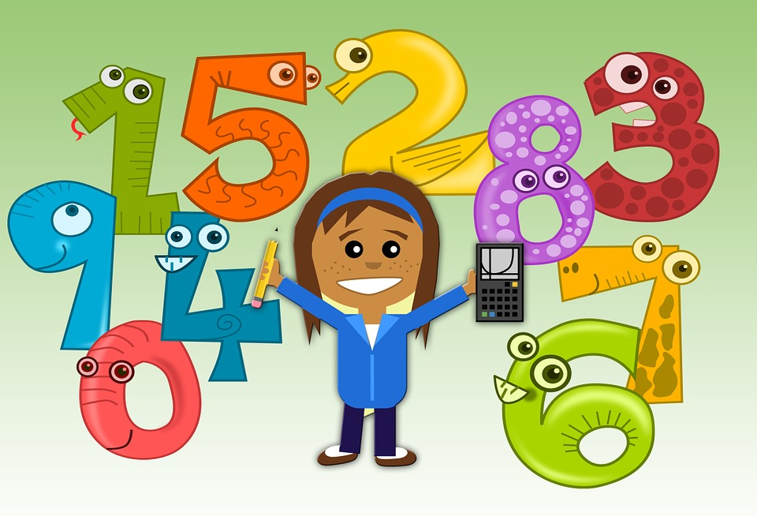

Go back to your zoo map and add detail to your map. I am looking forward to seeing them when you are back.

Add labels to your zoo.

OTHER!

NUMERACY!

P1