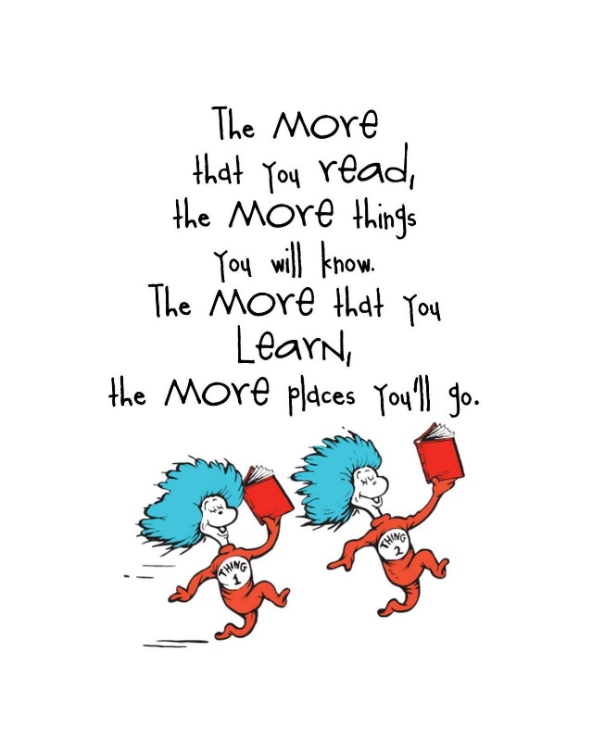C:\Documents and Settings\laura.gingell.SCHOOLS\Local Settings\Temporary Internet Files\Content.IE5\7GL6QQJA\MC900234428[1].WMFC:\Documents and Settings\laura.gingell.SCHOOLS\Local Settings\Temporary Internet Files\Content.IE5\7GL6QQJA\MC900198994[1].WMFC:\Documents and Settings\laura.gingell.SCHOOLS\Local Settings\Temporary Internet Files\Content.IE5\7GL6QQJA\MC900094743[1].WMF

Weekly Book ☺

Please log in to Oxford Owls (username and password at back of yellow jotter). Please have a look at the book ‘Fetch’. During the week have a listen to the audio version of the book and try both activities. Can you make up your own story to match the pictures?

Draw a map of a zoo you would like to go to.

Think of animal cages?

What else you do at the zoo?

OTHER!

P1

Practice saying your number bonds to 5 and 10.

NUMERACY!

P1

P1

Look at –at word family.

Can you make a word family flower?

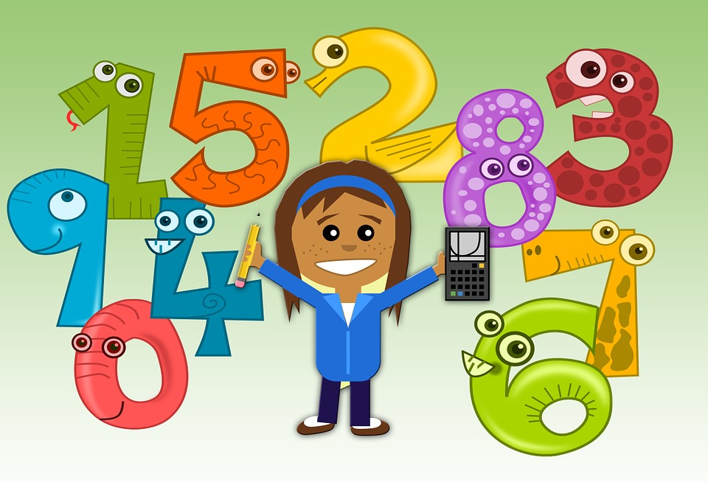

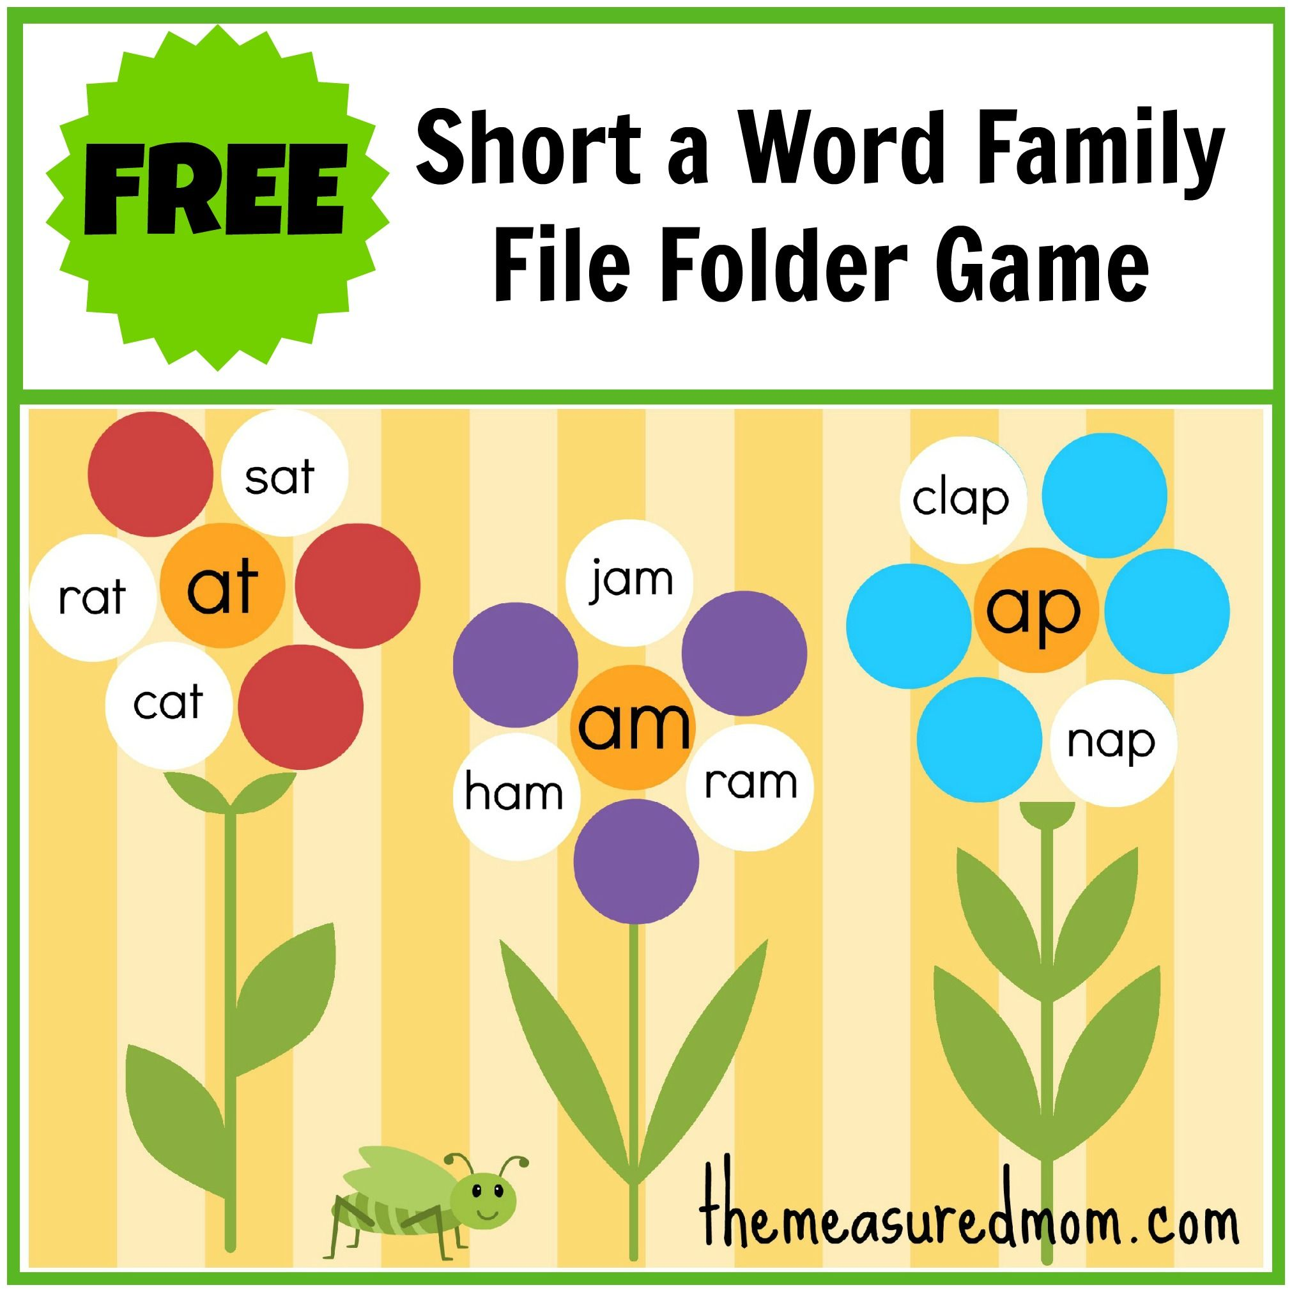

***P1 Activities 23.3.20***

**A note from your teacher**

Please complete these tasks in jotter provided each day. You will be able to share your learning with the class when you return to school.

LITERACY!