C:\Documents and Settings\laura.gingell.SCHOOLS\Local Settings\Temporary Internet Files\Content.IE5\7GL6QQJA\MC900234428[1].WMFC:\Documents and Settings\laura.gingell.SCHOOLS\Local Settings\Temporary Internet Files\Content.IE5\7GL6QQJA\MC900198994[1].WMFC:\Documents and Settings\laura.gingell.SCHOOLS\Local Settings\Temporary Internet Files\Content.IE5\7GL6QQJA\MC900094743[1].WMF

LITERACY!

Revise diagraph- ck

Practise forming ck neatly in your jotter and make a list of at least 10 ck words.

Blend at least 6 ck words using your letter cards.

Reading- Practise the first 20 Fry’s Words in your pack- Look, cover, say, write, check.

Read a book of your choice. Draw the front cover and a sentence saying what it is about.

***P3 Activities***

**A note from your teachers**

Please complete these tasks in the jotter provided each week. You will be able to share your learning with the class when you return to school.

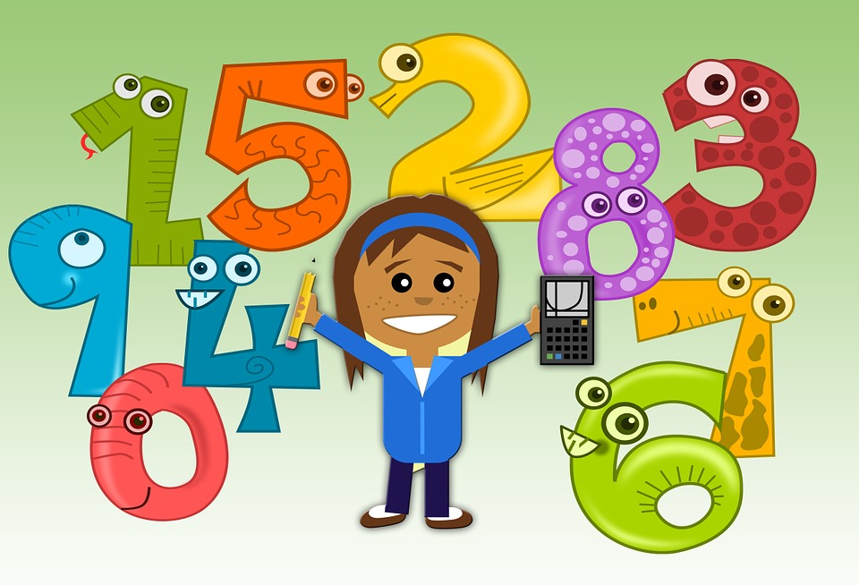

NUMERACY!

**Stars**- Count out objects to 20 using pencils, spoons, stones etc

**Triangles**-Practise counting on and back in 2’s, 5’s and 10’s.

**Squares**- Practise counting on and back in 2’s, 3’s, 4’s 5’s and 10’s

Log on to Sumdog and complete the challenge

(Passwords are in the back of your jotter)

<https://pages.sumdog.com/>

OTHER!

**Class Talk**

**Pick an animal or pet to talk about.**

**Prepare a 3-5 minute talk on your animal or pet.**

**You can show pictures, draw a picture or create a poster of the animal or pet to show with your talk.**