C:\Documents and Settings\laura.gingell.SCHOOLS\Local Settings\Temporary Internet Files\Content.IE5\7GL6QQJA\MC900198994[1].WMFC:\Documents and Settings\laura.gingell.SCHOOLS\Local Settings\Temporary Internet Files\Content.IE5\7GL6QQJA\MC900234428[1].WMFC:\Documents and Settings\laura.gingell.SCHOOLS\Local Settings\Temporary Internet Files\Content.IE5\7GL6QQJA\MC900094743[1].WMF

**Weekly task**

Log on over the week to Oxford Owls (login is at the back of your jotter) and choose to listen, read and complete the activities from **one** of the following books:

**Mild – ‘Fetch’**

**Spicy – ‘Big Bad Bug’**

**Hot – ‘Chicken Lickin’**

OTHER!

Draw a map of a zoo you would like to visit.

Think of what animal cages you would like to see?

What else would you do at the zoo?

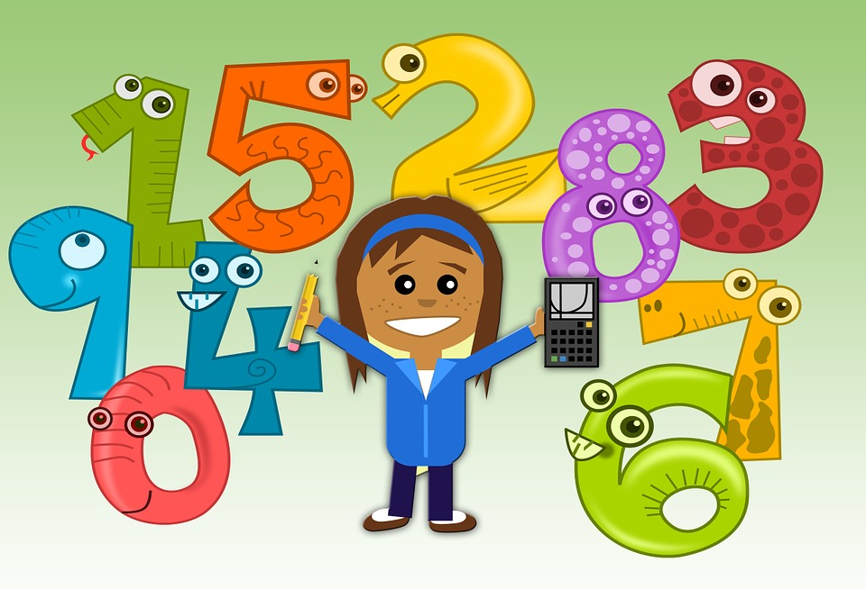

P2

Practice saying your number bonds to 5 and 10 consistently.

Know them in random order.

P1

Practice saying your number bonds to 5 and 10.

Use objects in the house to help you if needed.

P2

Look at sound ‘sh’

How many words can you write in your jotter with the ‘sh’ sound?

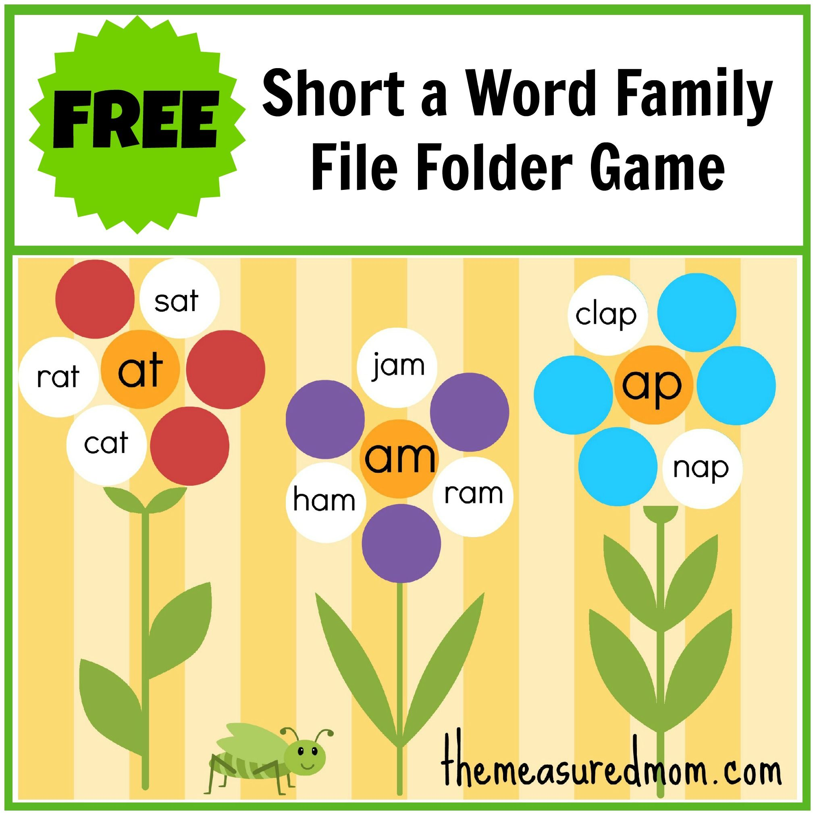

P1

Look at –‘at’ word family.

Can you make a word family flower

in your jotter?

***P2/1 Activities 23.3.20***

**A note from your teachers**

Please complete these tasks in jotter provided each day. You will be able to share your learning with the class when you return to school.

NUMERACY!

P1

LITERACY!