

**Kirkhill Nursery**

**and**

**Primary School**

**Promoting Positive Behaviour**



**Vision and Rationale**

At Kirkhill Nursery and Primary School we are committed to promoting positive behaviour in our school, playground and community through giving our children opportunities to learn skills for life in developing positive relationships with peers and adults. We have high expectations and standards of ourselves and our children, and believe that our children and staff should feel safe, happy and respected in an inclusive environment where they can all work together to develop, learn and teach.

Aims:

•To value all children as individuals promoting equal opportunities in all areas.

•To build self-esteem and to create explicit opportunities for recognising achievement in all areas through encouragement, praise and reward.

•To engage parents/carers, and other agencies where appropriate, in active partnership to develop and maintain high standards of behaviour in school and the wider community.

•To develop in all students a sense of self-discipline and an acceptance of responsibility for their own actions and the decisions they make.

•To develop in all pupils an awareness of their emotional and behavioural needs and the effect on themselves and others.

•To ensure that any form of discrimination, including bullying is addressed as part of promoting positive relationships. We follow West Lothian Promoting Positive Relationships in West Lothian Education Establishments policy and guidance.

Our behaviour approach is underpinned by the understanding that all behaviour – positive and negative – is rooted in the quality of relationships. Our Rights and Rights Actions (Appendix 2) have been developed by our children and set our standards for expected behaviour. Restorative Approaches to behaviour are at the heart of how we manage relationships to ensure the rights of all pupils to learn and grow with confidence. Four strategies underpin our approaches to positive behaviour: House Points/Pupil Voice (Kirkhill Chatter) (Appendix 3) – Golden Time (Appendix 4) – Steps to the Kirkhill Golden Club (Appendix 1) – Restorative Approaches (3 Effs) (Appendix 5). These to be displayed in classrooms and used as part of classroom management.

**Restorative Approaches**

Restorative Approaches are used to support the reparation of harm done through the wrong choices made by any individual in the school community. This process encourages the individual to take responsibility for their behaviour and recognise the damage they have done when they have hurt or upset another person. It also focuses on giving the ‘victim’ the opportunity to let the wrong doer know how they feel, decide what it is they need to feel better about the situation and identify consequences. Most importantly, it is about helping to repair relationships allowing everyone to move forward.

The Restorative Approach may take the form of a mediation (peer or adult mediator supporting those involved); a circle (group or class circle to discuss the situation and decide on the best way forward) or conference (involving SLT and/or parents/carers). The timing of the Restorative Approach is very important. It may not take place right after an incident, as all participants may not be ready to engage.

The three Effs will be used when carrying out a restorative conversation (Appendix 5)

Restorative Approaches involve going much deeper than handing out a punishment and its effects last longer. Research has shown that if children are not given an opportunity to resolve conflict at school this will often have a negative effect on the others around them.

**The Kirkhill Golden Club**

Entry into the Kirkhill Golden Club will be gained on reaching Step 5. Everyone will start the school year aiming to get from Step 1 to Step 5. Movement up the steps will be determined by how well our children **follow the rights and right actions.** At the end of each week class teachers will award stickers/Dojo points/dots (class teachers will decided how this works in each class) to children determined on their behaviour during that week. If children have lost Golden Time during the week or displayed poor behaviour in the playground and around the school then they will not receive the maximum amount of stickers/Dojo points/dots and this will slow their progress up the steps.

Once you have reached Step 5 you will have gained entry into the Kirkhill Golden Club and be invited to the end of term reward event. If once in the Kirkhill Golden Club children display behaviour which is not of a high standard then children may be moved down a step and have to regain their place in the club.

There may be some children who require an alternative route to the Golden Club steps. This could be done through individual behaviour charts/points system (eg Barnardo’s). Class teachers should discuss this with their line manager and Parent/Carer.

**Steps to Positive Behaviour**

**Entry into the Kirkhill Golden Club**

|  |  |  |
| --- | --- | --- |
|  | **Celebrating positive behaviour** | **Helping with inappropriate behaviour** |
| **1** | Praise and encouragement  from staff | Restorative discussion with staff -  1-1, group/circle, conference |
| **2** | 10 minutes free play in class | Loss of Golden Time |
| **3** | Visit Principal Teacher for reward | Visit SLT to discuss your behaviour (remain in at interval/lunch) |
| **4** | Visit Depute Headteacher – receive reward | Visit SLT to discuss your behaviour  (time out of class with SLT and loss of break) |
| **5** | Visit HT – entry to Kirkhill Golden Club | Visit SLT to discuss your behaviour – may result in a phone call or letter home |
|  | **Kirkhill Golden Club Membership**  Once you have reached Step 5, you will be invited to a special event at the end of each term | **Severe Clause** - if behaviour seriously hurts or harms others, or seriously disrupts learning, your teacher will send for the HT/DHT/PT You will go straight to Step 3, 4 or 5 |

Appendix 1

 Our Rights and Actions 

|  |  |
| --- | --- |
| Our Basic Rights | Our Actions |
| The right to an education. (Article 28) | To try our best and persevere with work. Use our brain wisely. |
| The right to play. (Article 31) | Use break and lunch time wisely for playing. |
| The right to privacy. (Article 16) | Respect other people’s bubbles and their property. |
| The right to be safe. (Article 19) | To be careful and look out for others. |
| The right to an opinion. (Article 13) | Listen to others and be fair. Take turns and respect what others have to say. |

Appendix 2

**House Points**

All of our children are in one of our four houses. House points are awarded to children for following our Right Actions and can be awarded by all adults in our school.

Each house is split into vertical groups who meet throughout the school year to discuss school issues and have their say in what happens in school. These are called ‘The Kirkhill Chatters’.

At the end of the school year all of the house points for each house for the whole year will be gathered and the winning house will receive a **BIG HOUSE PARTY** and win the House Trophy.

At the end of each term the House Team add up all of the points for each house and the winning house receive a 15 minute extra break during the last week of term.

House Points are recorded on the house shield in each classroom and counted by our House Team each week.



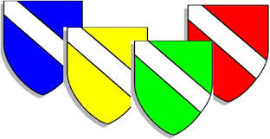





Appendix 3

**Golden Time**

**The ability to focus and concentrate in class is the basis of good quality learning and essential to making good progress at school.**



If poor behaviour continues you will be moved to red and you will lose Golden Time. This will affect how quickly you move up the steps.

**We rely on parental support to reinforce our very high expectations for behaviour.**

If after a verbal warning poor behaviour continues then your teacher will move you to amber.

Everyone starts each day on green as this is our daily expectation for good behaviour.

Everyone starts the week with 30 minutes of Golden Time.

**Golden Time is a weekly time to play and bond with friends and is how behaviour which follows our right actions is rewarded and unwanted behaviour is discouraged.**

**We all work together to keep the school safe, well-ordered and productive.**

Appendix 4

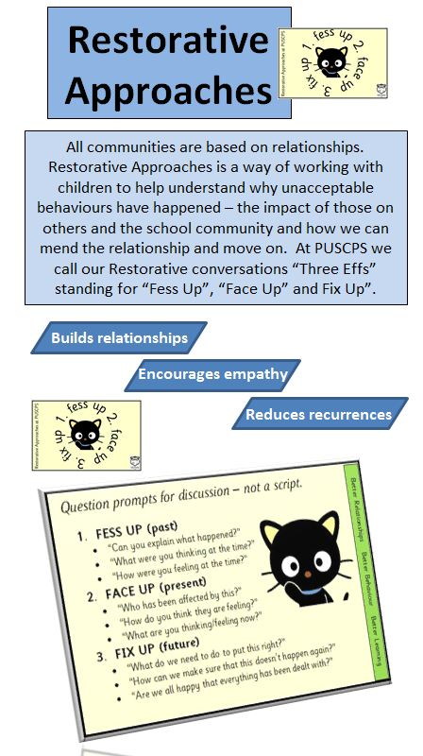****

All communities are based on relationships. Restorative Approaches is a way of working with children to help understand why unacceptable behaviours have happened – the impact of those on others and the school community and how we can mend the relationship and move on. At Kirkhill we call our Restorative conversations ‘Three Effs’ standing for ‘Fess Up’, ‘Face Up’ and ‘Fix Up’.

Appendix 5