MEN! MEN! MEN!
Calling all DADs
(Fathers, Grandads, Uncles or Male Significant Caregivers)
Bring the kids and join us for some activities at Kirkhill Primary School

Week 1: Construction Night - 23rd May 2018 from 6pm-7pm
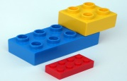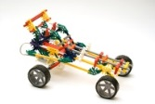

Week 2: Ukele and guitar - 28th May 2018 from 6pm-7pm
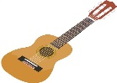

Week 3: Table Tennis - 4th June 2018 from 6pm-7pm
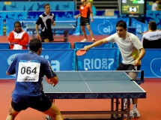
Week 4: Pizza night – 11th June 2018 from 6pm-7pm

Alternative activities
Let us know your thoughts for possible future events for next session

