
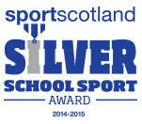

West Lothian Council
Education Services
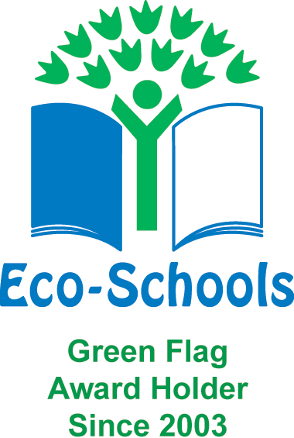

Kirkhill Primary School
wlkirkhill-ps@westlothian.org.uk
https://blogs.glowscotland.org.uk/wl/Kirkhill/
28 July 2026

Dear Parent / Carer
We would like you to come to our coffee morning in aid of Macmillan Cancer Support on Friday 7th October between 9.30am and 11.00am. As a class we have come up with lots of ideas. On the day we would like everyone in the school to dress down for a small donation.

Every class will be given a time to come along, with children paying 50p for a ticket. This ticket will get them juice, a biscuit and sweets. Tickets will be on sale from 23rd September with P4 issuing the tickets. We will be coming around classes in the next few weeks with ‘Guess How Many Sweets In The Jar’ for 10p a turn and Guess The Owl’s Birthday for 20p a turn. We hope to raise as much money as possible.
If you would like to join your child when their class will be attending the coffee morning the times are –

P1, P2/1 and P7 – 9.30am-9.50am
P4/3 and P7/6 – 9.50am-10.10am
P6 and P2 – 10.10am-10.30am
P5 and P3 – 10-45am-11.05am

If you have anything that you would like to donate for raffle prizes can you please send in to school by MONDAY 3rd OCTOBER or even some baking by the morning of FRIDAY 7th OCTOBER. We would greatly appreciate it.
Let’s help Kirkhill raise a great amount for MacMillan.
Thank you!
Primary 4

