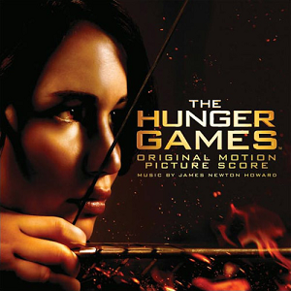

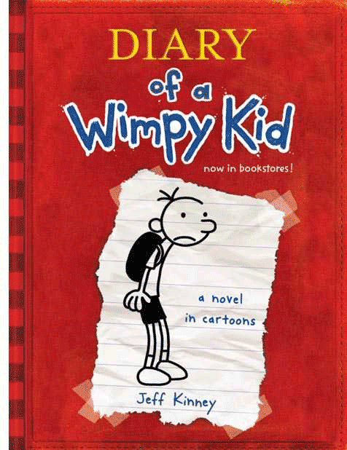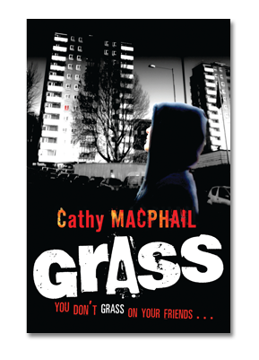

**Attention P6 and P7 pupils!**

Broxburn Academy **S6 students** invite you to join their annual book club.

At the book club you can **read** your own book, **talk** about your favourite books and characters and take part in **activities** with the Broxburn Academy S6 helpers.

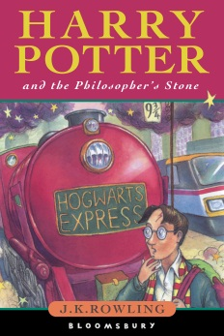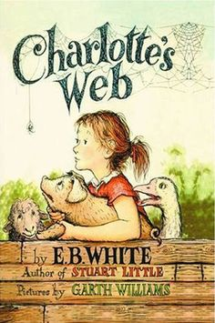If you would like to take part in this year’s book club please **speak to your class teacher** who will let you know when and where the book club will be meeting.