G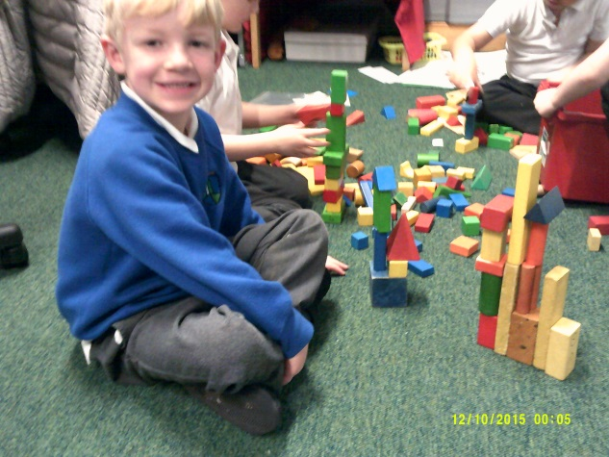 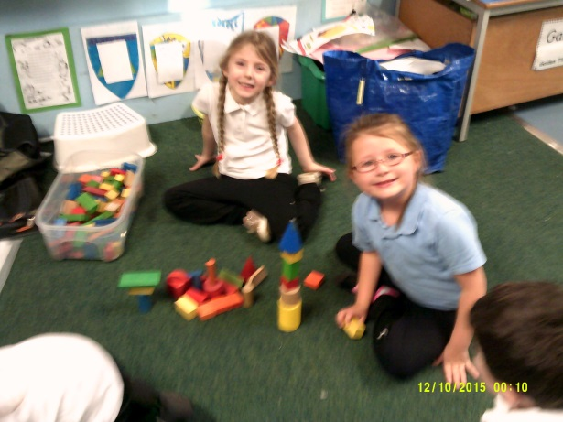
Greetings from P1D.
We have been learning about 2D and 3D shape. Here are some of our models we have made. Can you spot the shapes?
We love having BIG time in our class each morning. Here we are with some of our P7 carers who help us each morning.
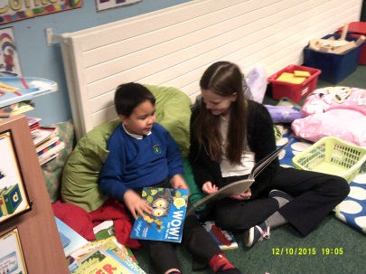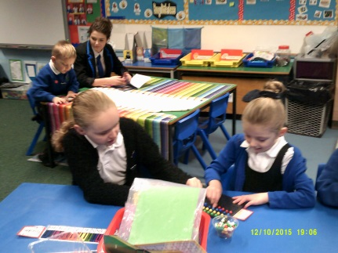

Look what Mason and Leah made during golden time.
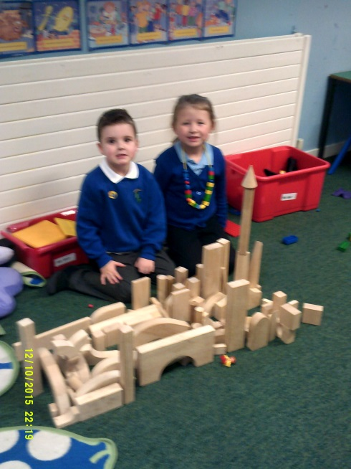

Primary 7S made board games with Miss Dunn during a health and wellbeing lesson. They worked really hard to create a game and we loved playing them. Their games had to –
- be Christmas themed
- include an active focus
- appropriate for P1 pupils to play.

Below are some photos of us all together playing the games. Some of the active things included – bunny hops, star jumps and running on the spot. These were board games that kept everyone busy and Miss Dunn was so proud of us all.
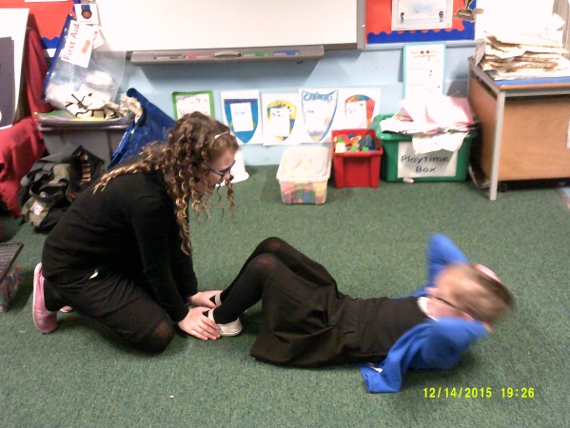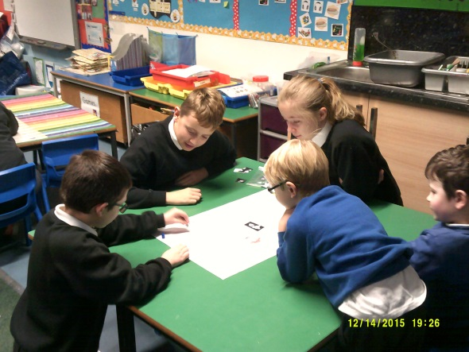
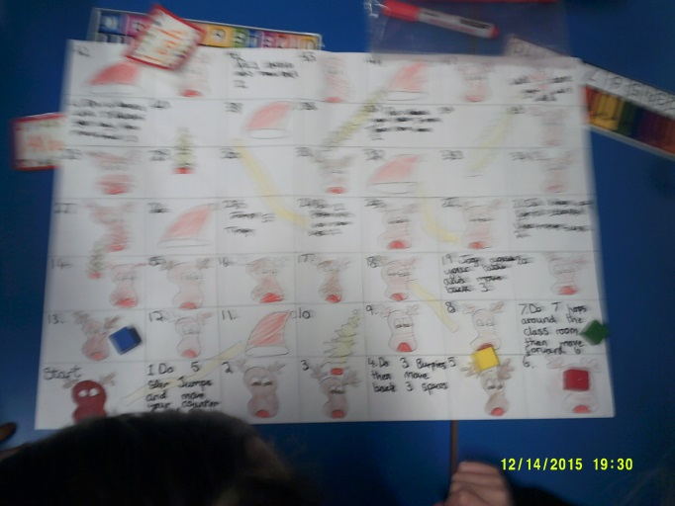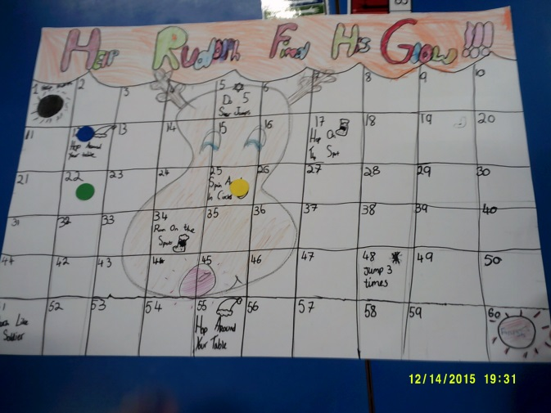

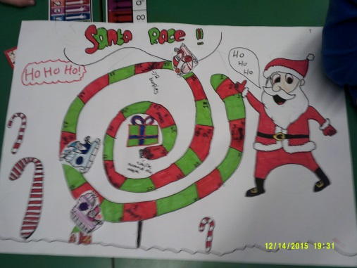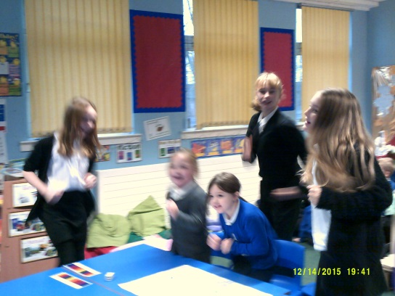
Some of the feedback we gave about the games to P7 was words like – fab, excellent, amazing, tiring, fun, and active.

“I liked playing with the P7’s” – Tiana
“My favourite game was the Santa game” – Adele
“I liked the exercises” – Robert and Chloe
“It was fun” – Lucas
“I liked playing the Santa race” – Cadence

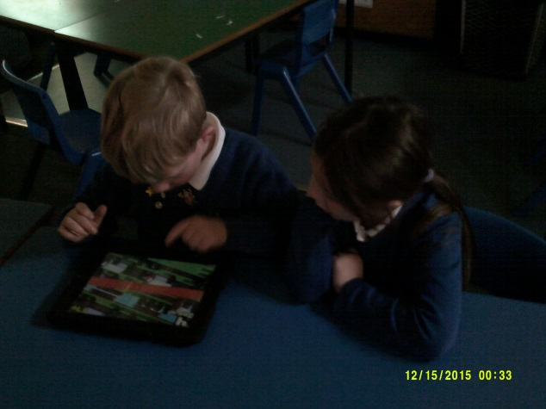
We won stars on the doors along with P3 so we have been able to use the Ipads for the last week of term. We have had great fun getting to use these.

Finally Merry Christmas to everyone from P1D, Miss Dunn and Mrs Reid.
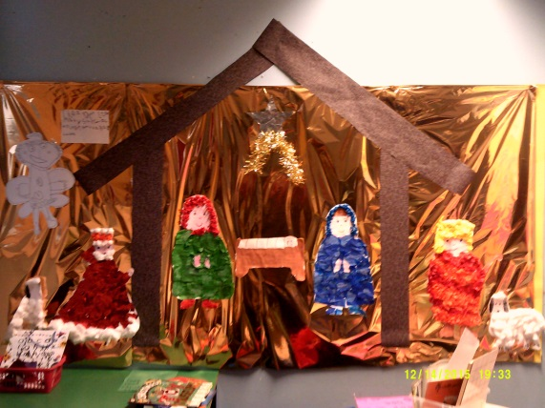This is one of our classroom displays.

