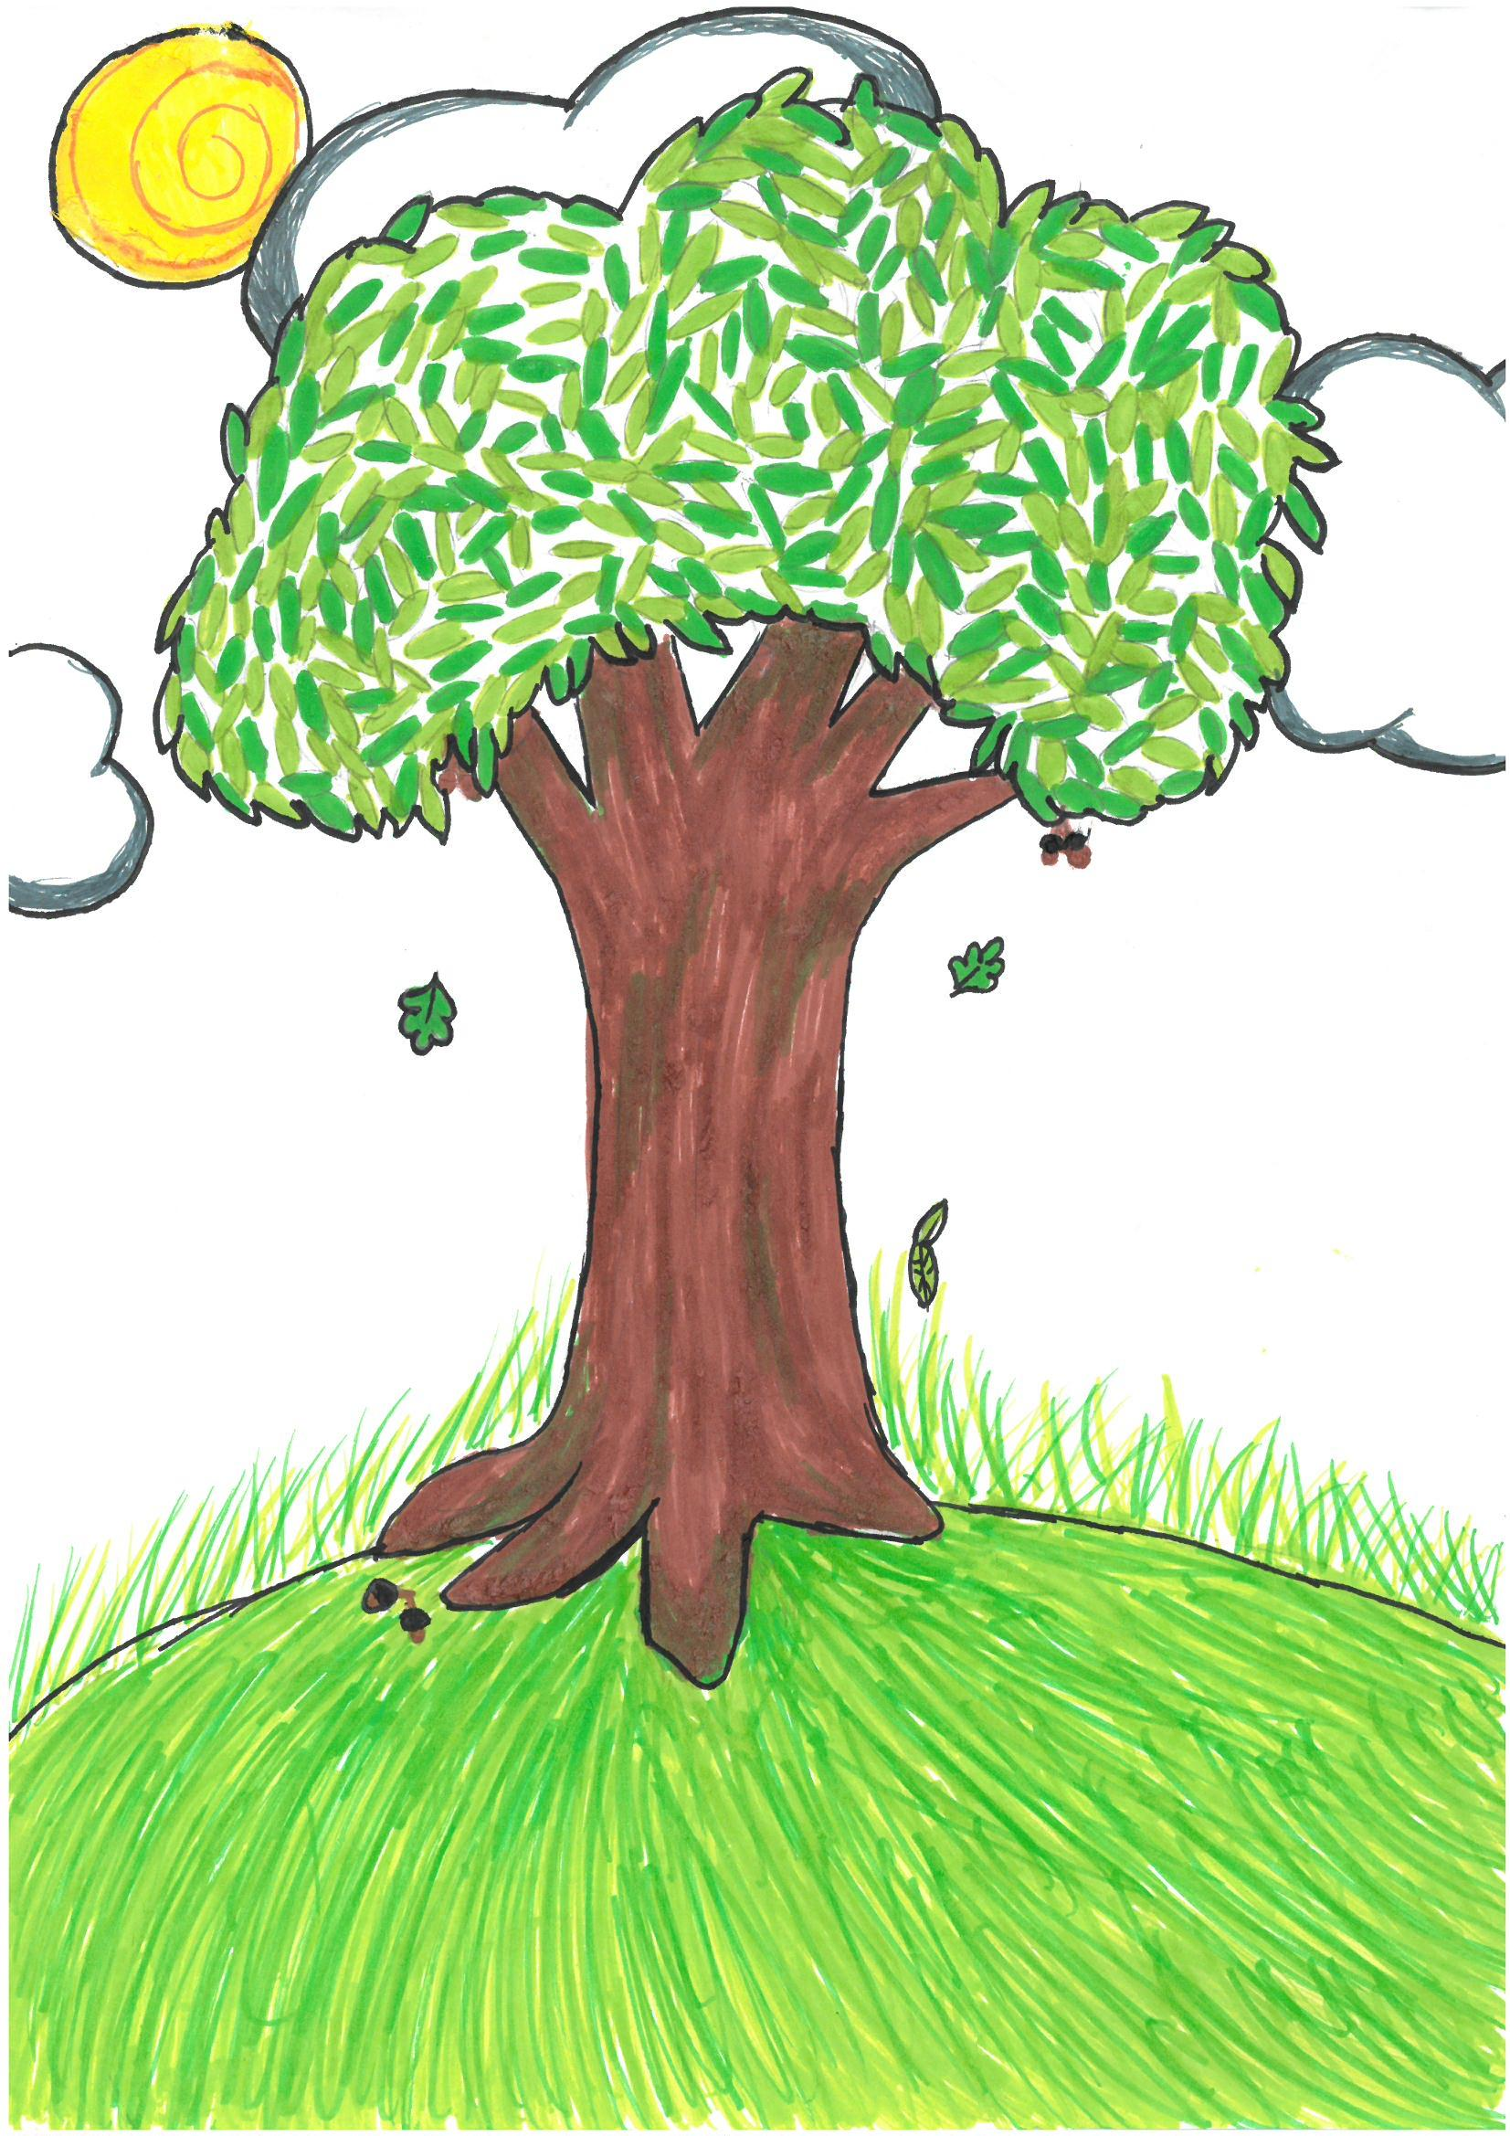

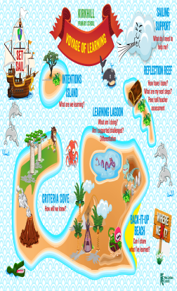
Curriculum Areas
Literacy and English
Numeracy and Mathematics
Health and Wellbeing
Expressive Arts
Technologies
Science
R.M.E.
Social Studies

Curriculum for Excellence
Experiences and Outcomes

Vision for Our Curriculum
We aim to create a welcoming, safe and happy environment for our whole school community which enables children to develop skills for life, learning and work through raised aspirations for learning where all meet their full potential and flourish.
GIRFEC
Developing Scotland’s
Young Workforce
Wellbeing Indicators
Rights Respecting School
National
Improvement
Framework
Core Learning, Teaching and Assessment Policy
Learning, Teaching & Assessment
- Active and engaging
- Challenging
- Shared expectations and standards
- Effective feedback
- Learning intentions and success criteria
- Profiling
- Collaborative
- Developing thinking skills
- Differentiation
- Effective questioning
The Rationale for Our Curriculum (March 2017)

