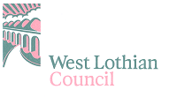

Kirkhill Nursery and Primary School

SCHOOL IMPROVEMENT PLAN

2015-2016

Safe

Healthy

Achieving

Nurtured

Included

Responsible

Respected

Active

Learning
and
Teaching

Vision
and
Leadership

Partnership

People

Culture
and
Ethos
Successful
Learner
Confident Individual
Responsible Citizen
Effective Contributor
The West Lothian Context

West Lothian Council is committed to delivering the best possible outcomes for children and young people so that they have the best start in life and are ready to succeed by following the principles of Curriculum for Excellence (CfE) and Getting it Right for Every Child (GIRFEC).

Within Curriculum for Excellence, every child and young person is entitled to experience a curriculum which is coherent from 3-18. Those planning the curriculum have a responsibility to work in partnership with others to enable children and young people to move smoothly between key transition points, building on prior learning and achievement in a manner appropriate to the learning needs of the individual. This should ensure that young people are well placed to move into positive destinations and adult life.

The Corporate Plan sets the strategic direction and our priorities for West Lothian Council. There are eight priorities that we, and our community, believe can make a lasting and sustainable impact on the local area and improve the lives of residents in West Lothian.

Priority 1: Delivering positive outcomes and early interventions for early years
Priority 2: Improving the employment position in West Lothian
Priority 3: Improving attainment and positive destinations for school children
Priority 4: Improving the quality of life for older people
Priority 5: Minimising poverty, the cycle of deprivation and promoting equality
Priority 6: Reducing crime and improving community safety
Priority 7: Delivering positive outcomes on health
Priority 8: Protecting the built and natural environment

The Corporate Plan informs Education Services Management Plan to ensure our work impacts positively on services for children and young people. Education Services focuses particularly on priorities 1, 2 and 3.

Education Services Management Plan

Education Services works towards achieving the key strategic aims of the council, in partnership with schools. In particular, Education Services aims to improve opportunities for children and young people by:

- Raising standards of attainment and achievement
- Improving employability and positive destinations for all school leavers
- Improving the learning environment
- Promoting equality of access to education
- Developing values and citizenship
- Promoting learning for life and encouraging a creative, enterprising and ambitious outlook.

Working with a range of partners, the key purpose of our work is to continuously raise attainment and achievement for all children and young people in West Lothian, ensuring that our young people succeed in securing a positive and sustained destination after school.

Factors Influencing the Improvement Plan

School factors
- Appointment of new Head Teacher (August 2015)
- 2 new members of teaching staff
- Establishing new nurture group
- GIRFEC – SFL and Nurture Strategy development
- Staffing and budgetary constraints
- CEM assessments
- Cluster agreed Improvement Priorities
- Change in leadership of three cluster primary schools

Local authority factors
- Single Outcome agreement
- Corporate Plan
- Integrated Children’s Services Plan (Life Stages)
- Education Services Management Plan
- Moving Forward Together
- Curriculum for Excellence Implementation Guidance
- Raising attainment, including for those at risk of missing out
- Increased entitlement to early years provision

National factors

- Single Outcome agreement
- Getting it Right for Every child (GIRFEC)
- Curriculum for Excellence
- National Qualifications
- Child Protection Issues / Guidance
- National Legislation: Children and Young People (Scotland) Act 2014
- GTCS revised standards and professional update

Our School Values, Vision and Aims:

Vision Statement

At Kirkhill we promise to educate hearts and minds by providing education of the highest quality. We value the following attributes in which our school and its wider community agree –
RESPECT, HONESTY, FAIRNESS, EMPATHY and PERSEVERANCE.

School Aims:

- Learning and Teaching

- To deliver a curriculum based on the seven principles of CfE.
- To improve the quality of educational experiences for learners by promoting and recognising achievement and encouraging each child to realise their potential and develop skills for learning, life and work.
- To make learning fun and develop positive attitudes.

- Vision and Leadership
- To ensure that the leadership team provide high quality leadership, management and support for all, developing capacity for distributive leadership at every level.
- To ensure that the leadership team improve the quality of educational experiences for learners through a programme of continuing lifelong professional learning for staff.
- To ensure the leadership team develop capacity for self- evaluation in staff
- To ensure that the leadership team provide and manage high quality resources fit for purpose

- Partnership
- To maintain and build upon the very good partnerships with outside agencies, pupils, parents and the wider local and world- wide community.
- To ensure that everyone at Kirkhill promotes positive relationships for the benefit of all.

- People
- To continue to develop pupil voice from nursery to P7 giving pupils increased opportunities to take responsibility for their learning
- To encourage independence from nursery to P7 through involving our learners in the problem solving and decision making process

- Culture and Ethos

- To provide a welcoming and caring environment in which each learner is valued and supported.
- To be inclusive and support every child in achieving his/her full potential.
- To develop an ethos of respect and tolerance towards all others in the school community and beyond.
- To implement the principles of the well-being wheel
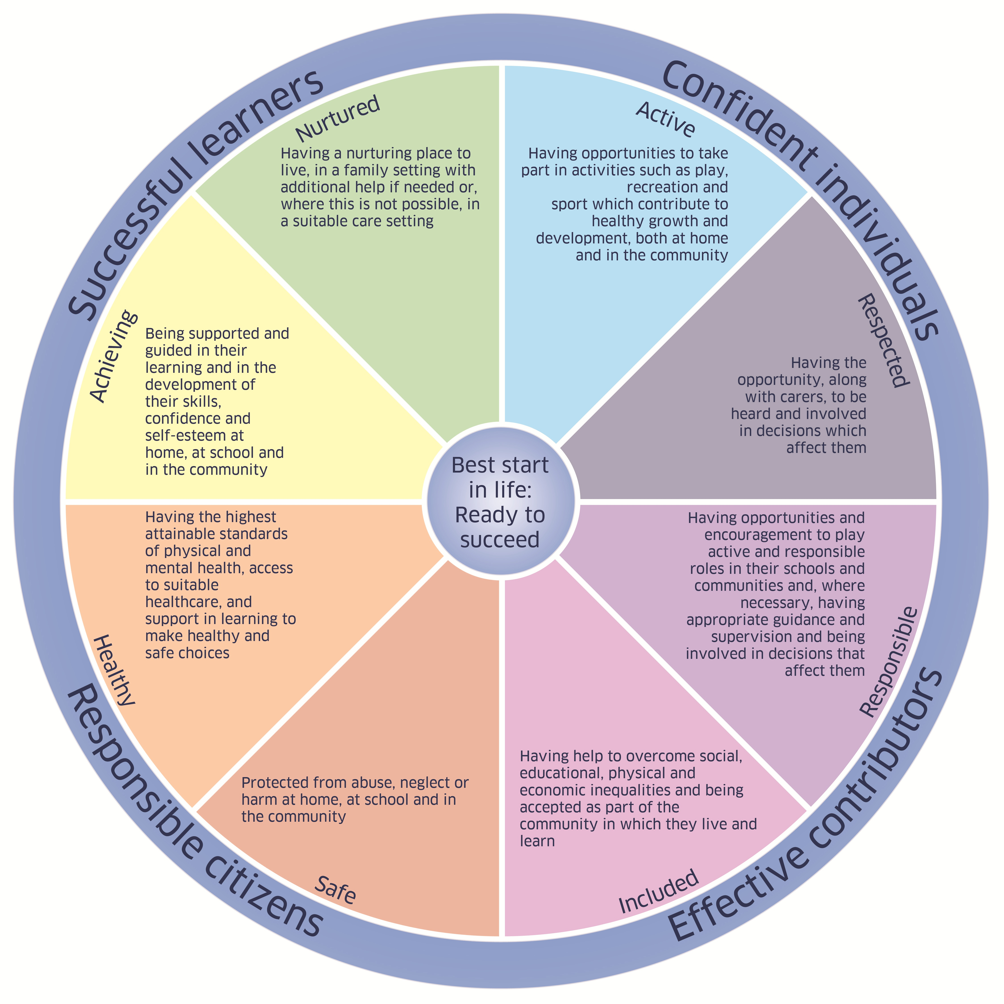

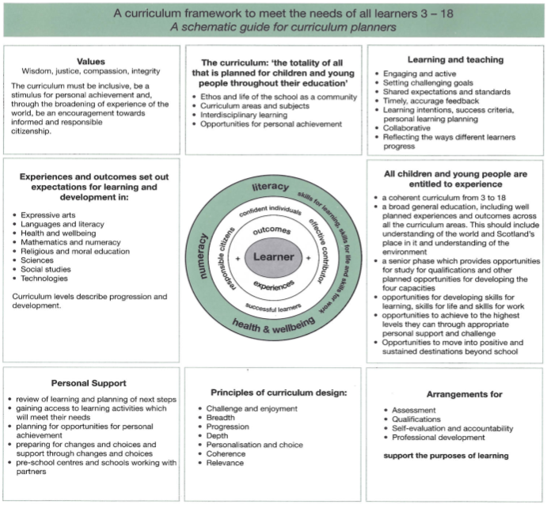

Strategic Curriculum Plan (Three Years)

Session | Area for Development | Desired Outcomes
2013-2014 | Developments from Review Action Plan  Curriculum  Progressive and challenging curriculum programmes from nursery to P7  Coherent and consistent approaches to planning which include a clear focus for assessment and evaluation which informs next steps in learning | 1.1 Increase Staff knowledge of the factors which will inform meaningful curriculum programmes  1.2 To develop and evaluate a framework for skills progression  1.3 To review and update existing resources  2.1 Audit Current planning Nursery to P7 and adapt proformas to include assessment and evaluation to inform next steps in learning as required  2.2Crea 2.2 To create more opportunities for Collaborative planning across all stages with emphasis on progression at key transitional stages.  2.3 Create more opportunities for parents to engage with target setting and reflection on progress made.  2.4 Review and evaluate new planning arrangements
 | Quality Assurance  An effective system to monitor and track progress in learning and development.  Robust quality assurance practices. | 3.1 Best Practice visits to cluster and schools out with the cluster  3.2 Analysis of Pips and CEM tests  4.1 Continue with SMT Monitoring Calendar  4.2 To develop staff capacity for self -evaluation
2014-2015 | Learning and Teaching Approaches and Curriculum Development | - To develop progressive and challenging programmes from Nursery to Primary 7.
 | Development of a continuous improvement culture | - To build capacity within school to ensure quality improvement through self-evaluation is rigorous, systematic and positively impacts on learning and teaching and involves all appropriate partners
2015-2016 | Raise attainment for all learners through engaging with CfE Es and Os, progression pathways, tracking and evaluative evidence and Education Scotland Significant Aspects of Learning (SAL). Planning for clear progression taking account of the CfE design principles while reducing bureaucracy and improving coherence; pupils included in planning to develop relevance, personalisation and choice. | - Planning takes account of pupil views to develop relevance, personalisation and choice.  - Long term planning and medium term planning are guided by backward mapping information, Progression Pathways, evaluation of learning, tracking information and Significant Aspects of learning and takes account of changing priorities  - Pace and challenge across the curriculum is improved
 | To raise attainment in literacy and numeracy for all pupils through collegiate moderation and development of pedagogy, planning and assessment. | - To further develop learning and teaching approaches in numeracy and mathematics across the school to ensure all children are supported and challenged in their learning at a pace appropriate to their needs.  - Staff engagement in moderation activities and professional reading enhances staff knowledge of learning and teaching approaches and the impact on children’s learning and attainment.  - Quality Improvement and self-evaluation practices lead to improvements in performance and raised attainment in literacy and numeracy in a culture where critical reflection and professional learning enhance outcomes for all children

Priority: Raising Attainment |  |  | 2015 – 2016
Area for Development 1: Raise attainment for all learners through engaging with CfE Es and Os, progression pathways, tracking and evaluative evidence and Education Scotland Significant Aspects of Learning (SALs). Planning for clear progression taking account of the CfE design principles while reducing bureaucracy and improving coherence; pupils included in planning to develop relevance, personalisation and choice.
School’s current position: Through self-evaluation practices, development of our raising attainment strategy and analysis of CEM results, it is clear that there is a need for staff to engage with the CfE Es and Os to ensure that the children are receiving their entitlement to a broad general education. There is an identified need for there to be consistent and robust backward mapping, forward planning, evaluation (using Education Scotland Significant Aspects of Learning) and tracking systems in place across the school that are not overly bureaucratic or repetitive and which are purposeful, meaningful and coherent and lead to appropriate pace and challenge for all children.
Desired Outcomes  Backward mapping information is used by all staff to ensure that children experience breadth and depth in learning across each stage and CfE level and there is a clear and flexible annual plan in place. | Implementation Process (Actions)  - Introduce backward mapping across Early to Second Levels and all staff begin to use for this session  - Staff use CfE outcomes to develop their annual plan and identify contexts for learning taking into account aspects of personalisation and choice  - Professional dialogue opportunities to discuss information gathered from backward mapping documents  - Professional reading opportunities built into staff training sessions to further develop professional dialogue | By whom  HT  All staff  HT  All staff  SLT  All staff  SLT  All staff |  | Time Scale  Sept ‘15  Sept ‘15  Sept ‘15  Oct ‘15  Sept ’15 – Dec ‘15  Nov ‘15 | Resources  September INSET  September INSET  FP & Attainment Meetings  CAT/Staff Meeting GTCS professional reading  BtC documents | Monitoring  SLT – FP & Attainment Meetings – professional dialogue  Monitoring of Forward Plans  SLT – FP & Attainment Meetings – professional dialogue  Monitoring of Forward Plans  SLT – professional dialogue  Forward plan monitoring  SLT – professional dialogue
Medium term planning takes into account backward mapping information, progression pathways, evaluations of learning and tracking information and leads to an increased pace for all across the curriculum. | - Introduce learning across the curriculum planning (LAC) for contexts for learning to ensure that coherent links are made across the curriculum and elements of personalisation and choice are taken into consideration  - Further engagement with progression pathways for Literacy, Numeracy and Health Wellbeing and all staff use to plan for progressive and coherent learning experiences and these are used by all teaching staff to plan for learning and teaching  - Moderation of planning activities are designed to support staff in the development of new planning processes | SLT  All staff  SLT  All staff  All staff |  | Sept ‘15  October ‘15  Dec ‘15 | September INSET  October INSET  Oct INSET  Staff Meetings  Nov CAT | SLT – monitoring of forward plans/classroom observations/structured walks/QI findings summaries  Monitoring of forward planning folders  Classroom observations  Pupil voice  Professional dialogue
Evaluation of learning and teaching  Support for Identified Children | - Introduce evaluations of learning in LIT/NUM and work collegiately to develop use of evaluative language taking into account SALs and learning statements  - Introduce Support for Identified Children to focus on children who require support and challenge and identify resources to support this  - Moderation activities to support staff in developing the use of evaluative language asking the ‘so what?’ question | SLT  All staff  SLT  All staff  SfL  All staff |  | October ‘15  August ‘15  June ‘16 | Oct INSET  CAT session  CAT session (August ’15)  INSET/CAT sessions | SLT  FP & Attainment Meetings  FP & Attainment monitoring  SLT  FP & Attainment Meetings  FP & Attainment monitoring  Classroom observations  Professional dialogue
Tracking and monitoring | - Introduce new tracking sheets which show children’s progress across Early-Second Levels  - Professional dialogue and moderation sessions to begin the process of embedding into practice  - Development of Core Learning and Teaching Policy which is informed by practice | SLT  All staff  SLT  All staff  SLT |  | Nov ‘15  Dec ‘15  June ‘16 | CAT session  FP & Attainment Meetings  INSET/CAT sessions  Staff meetings | SLT  FP & Attainment monitoring  FP & Attainment meetings  Professional dialogue  Classroom observations
Evaluation:  Are backward mapping, forward planning, progression pathways, evaluations of learning and tracking being used to ensure that children are receiving their entitlement to a broad general education and being supported and challenged in their learning?  Are evaluations of learning leading to the identification of next steps in learning and that the children are experiencing an appropriate pace of learning dependent on their ability level?  Are moderation activities ensuring that all staff are able to plan effectively across the curriculum and this is leading to increased pace in learning and raised attainment across the school?  Are all staff using tracking information to make professional judgements about learning and to identify next steps to further raise attainment? |  |  |  | Evidence (How do we know?)  - Monitoring of forward planning folders, evaluations and Support for Identified Children/IEPs  - FP & Attainment Meetings  - Classroom observations  - Pupil voice  - Professional dialogue and discussion  - Staff using evaluative evidence to identify next steps in learning  - Children are able to talk about their learning and next steps  - Classroom observations  - Monitoring of children’s work  - FP & Attainment Meetings  - Consistency of approach across the whole school  - Information used at points of transition to ensure continuity in learning  - Professional dialogue  - FP & Attainment Meetings  - Monitoring of evaluations and Support for Identified Children/IEPs  - PIPs/CEM analysis  - Learner’s Journeys (Nursery and P1)  - FP & Attainment Meetings  - Professional dialogue  - PIPs/CEM analysis  - Learner’s Journeys (Nursery and P1)

Priority: Raising Attainment (Pedagogy) |  |  | 2015-2016
Area for Development 2: To raise attainment in literacy and numeracy for all pupils through collegiate moderation and development of resources, pedagogy, planning and assessment.
School’s current position: Resources for literacy and numeracy are in place and some staff have accessed these. SEAL training as a cluster took place during Session 2014-2015 and previous training in using Hearsay, Reading Routes and Write to the Top was carried out, but requires additional time to be ensure these are embedded, consistently, across practice and are leading to improvement in attainment in literacy and numeracy. As part of SIP priority 1 a more consistent approach to planning for learning in Literacy and Numeracy using Es and Os, progression pathways and evaluations of learning, taking into account Education Scotland SALs, will ensure an appropriate pace of learning for all children and this will compliment priority 1.
Desired Outcomes | Implementation Process (Actions) | By whom |  | Time Scale | Resources | Monitoring
- Attainment across numeracy will be improved for all learners | Review and develop current practice in numeracy developing SEAL approaches across the school using the progression pathways  Work with cluster to achieve consistency of practice and make use of lead learners in SEAL to continue to embed practice. Encourage staff to use and contribute to SEAL resource pages on GLOW and to promote peer visits within schools to share practice  Engagement with mental maths  framework and numeracy pathway to support  planning for effective learning and teaching  including advanced SEAL strategies.  Work with cluster to develop resources to empower parents to support numeracy learning at home including planning for a curricular evening/open morning/shared starts with a focus in numeracy/mathematics.  Moderate practice and assessment to identify expectation for pace across the school and develop tracking and monitoring approaches (Priority 1). | SLT  All staff  Cluster  All staff  All staff  SEAL Champions  All staff  Cluster  All staff |  | Dec ‘15  Dec ’15 –  April ‘16  June ‘16  May ‘16  Dec ’15 – April ‘16 | CAT/INSET  SEAL resources  Cluster CAT  GLOW access  October INSET  Cluster CAT  Cluster CAT  Curriculum Evening  Open Morning  Shared Starts (P1)  Cluster CAT  CAT session | SLT  Classroom observations  FP & Attainment Meetings  FP & Attainment Monitoring  Collegiate development discussions  CEM/PIPS/assessment information  SLT  FP & Attainment Meetings  FP & Attainment Monitoring  Parent evaluations  Observations  Collegiate development discussions
- Attainment across literacy will be improved for all learners | Review current practice and develop approaches to using selected resources to develop literacy teaching and assessment:  - Write to the Top (Writing)  - Big Talk (Emergent writing & talking)  - Reading Routes (Reading)  - Hearsay (Listening & Talking)  - NFER spelling  Work across stages in school and across the cluster to moderate practice and develop plans to include high quality teaching and learning and assessment using these resources.  Moderate practice and assessment to identify expectation for pace across the school and develop tracking and monitoring approaches. | SLT and Cluster HTs  All staff  Peer partners  Cluster  Peer partners  Cluster |  | March ‘16  April ‘16  June ‘16 | Resource packs for Hearsay, Reading Routes and Write to the Top available for all staff  CAT/INSET  Peer partner time  Cluster CAT  CAT  CAT/INSET  Cluster CAT | SLT  Classroom observations  Peer partner observations  FP & Attainment Meetings  Collegiate development discussions  Collegiate development discussions  PIPs/CEM analysis
Evaluation:  - Are SEAL strategies used across the school – consistently in early level and in a targeted way at upper stages?  - Has cluster work led to an increase in consistency of approach in numeracy?  - Are teachers involved in the moderation of work and the discussion of pace and challenge – including conversations regarding pupil attainment including nursery?  - Is there an improvement in attainment in reading, writing and maths across the stages? |  |  |  | Evidence (How do we know?)  - Classroom observations  - Peer moderations  - Pupil discussions  - FP & Attainment meeting discussions  - Parent feedback  - Assessment and PIPs/CEM data

Additional Tasks 2015-16  Work towards Rights Respecting Schools – Level 1 Award | Responsibilities  HT  (x2 CT)
Continued engagement 1 + 2 Modern Language developments | PT  (x1 Development Officer/RCC Teacher)
Develop SfL and Nurture Group Strategy (GIRFEC) | HT/DHT  (x1 SfL Teacher/x1 Nurture Development Officer/Nurture Teacher)
Didbook developments across P5-7  Development of review of learning procedures in P1-4 (Learners Journeys and Review Jotters) | HT/DHT  All staff
Continued development of professional learning culture (professional update) – professional reading groups/professional enquiry learning | HT
Growing with Confidence introduced across all cluster primary schools | PT  All staff
Development of PRD processes in line with Professional Update – engagement with GTCS professional standards as means to evaluate practice and identify next steps for professional learning and development | HT/DHT/PT  All staff

