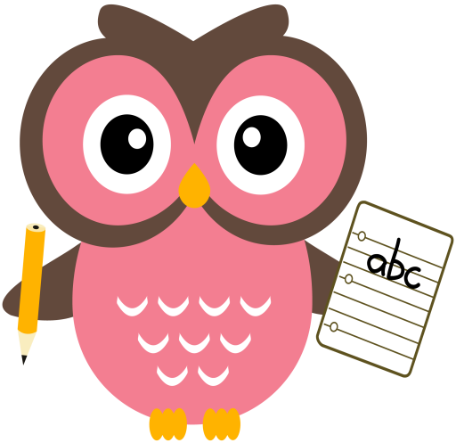

**Maths**

* Practise counting forwards to 100 and beyond and backwards from 30. Try to start and stop at different numbers in the range.

(number line to support)

* Practise number formation.
* What number comes after/before/ in between a number within 20/30.
* Practise counting forwards in 2’s to 20 and in 5’s 10’s to 100.
* Hit the Button ‘Make 10’

<https://www.topmarks.co.uk/maths-games/hit-the-button>

**Literacy**

This term we are continuing to read and write words containing long vowel sounds and introducing Block 3 tricky words.

**Word building:**

* Revision of the following sounds:

sh ch wh th ai/ay ee/ea igh/y oa/ow oo/ew oi/oy ou/ow

(sound booklet to support)

* New sound –au/aw

Suggested words: Paul maul

jaw saw paw

**Home Learning:**

Mon: Sounds – ou

Tues: Sounds – ow

Wed: Sounds – ou

Thurs: Sounds – ow

**Tricky words:**

* Revision of Block 1 and 2 tricky words.
* New tricky words Block 3:

where what why

**Term 2**

**2020**

**Reading**

* Read the story taking note of punctuation to read with fluency and expression.
* Go over speedy sounds.
* Choose one activity from Reading Task Map