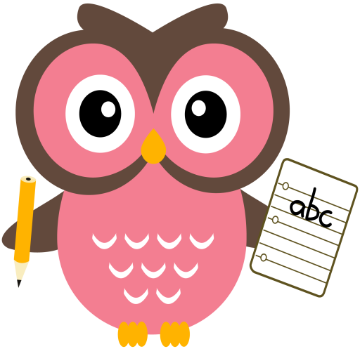

**Literacy**

We are learning our sounds and how they are formed. In your child’s folder there are initial sound cards for them to practise wordbuilding. Examples of some words to practise are attached.

**Word building Revision Week:**

* Revision of the following sounds:

a t p i s m r e h d o g f u b l c ck j v w

(see rhymes for letter formation)

* Can you identify each sound?
* Can you think of a word which begins/ends with the sound? e.g qu – queen, x - fox , y – yoghurt,

Z - buzz

* Can you remember the rhyme?
* **Mon:** soundqu word- want
* **Tues:** sound x word - saw
* **Wed:** sound y word – no
* **Thu:** sound z

**Revision of tricky words:**

I the to he me is his put was

Please find attached examples of words to practice.

Please see an example of word-building with the sounds on the following clip online:

<https://youtu.be/TkXcabDUg7Q>

**Maths**

* We are working on number bonds within 5 and 10. We are using numicon, counters and our fingers to support.
* Practise counting forwards and backwards up to number 20 and beyond if possible and starting at different numbers, not just 1.
* One more/one less than a given number within 10.
* Practise number formation using the jotter and number strip.
* Addition to 10 game.

<https://www.topmarks.co.uk/addition/addition-to-10>

**Term 2**

**2020**

**Reading**

Oxford Reading Tree Picture book

* Read the story
* Describe what you see.
* Point things out.
* Retell the story