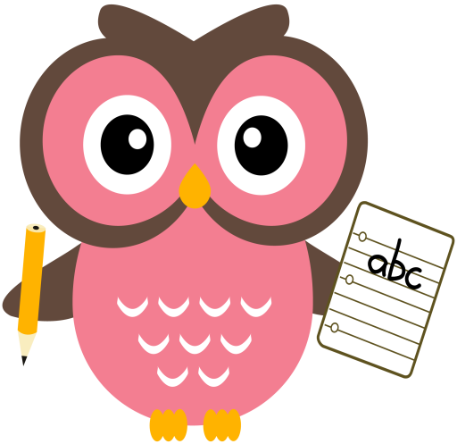

**Literacy**

This term we are continuing to read and write words containing long vowel sounds and introducing Block 3 tricky words.

**Word building:**

* Revision of the following sounds:

sh ch wh th ai/ay ee/ea igh/y oa/ow oo/ew

(sound booklet to support)

* New sound –oi/oy

Suggested words: boy toy joy

soil boil foil

**Home Learning:**

Mon: Sounds – oi

Tues: Sounds – oy

Wed: Sounds – oi

Thurs: Sounds – oy

**Tricky words:**

* Revision of Block 1 and 2 tricky words.
* New tricky words Block 3:

any water many

**Maths**

* Practise counting forwards to 50 and beyond and backwards from 30. Try to start and stop at different numbers in the range.

(number line to support)

* Practise number formation.
* What number comes after/before/ in between a number within 20/30.
* Practise counting forwards in 2’s to 20 and in 5’s 10’s to 100. Copy the link to practise counting in 2’s to 100 with Jack Hartman. https://youtu.be/OCxvNtrcDIs

**Term 2**

**2020**

**Reading**

* Read the story taking note of punctuation to read with fluency and expression.
* Go over speedy sounds.
* Choose one activity from Reading Task Map