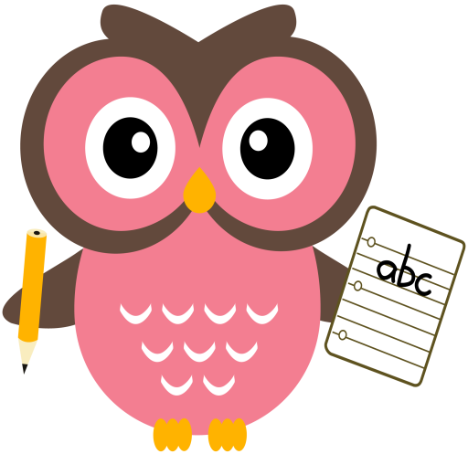

**Literacy**

We are learning our sounds and how they are formed. In your child’s folder there are initial sound cards for them to practise wordbuilding. Examples of some words to practise are attached.

**Word building:**

* Revision of the following sounds:

a t p i s m r e h d o g f u b l c ck

(see rhymes for letter formation)

* Can you identify each sound?
* Can you think of a word which begins with the sound? e.g j – jog, w – web, v - vet
* Can you remember the rhyme?
* **Mon:** sound **–** j word- his
* **Tues:** sound – v word - put
* **Wed:** sound – w word – was

Please find attached examples of words to practice.

Please see an example of word-building with the sounds on the following clip online:

<https://youtu.be/TkXcabDUg7Q>

**Maths**

* Practise counting forwards and backwards up to number 20 and beyond if possible and starting at different numbers, not just 1.
* One more/one less than a given number within 10.
* Practise number formation using the jotter and number strip.
* What number comes after/before/ in between a number within 10 and beyond if possible.
* Join in with number rhymes

<https://www.bbc.co.uk/teach/school-radio/nursery-rhymes-counting-songs/zn67kmn>

**Term 2**

**2020**

**Reading**

Oxford Reading Tree Picture book

* Read the story
* Describe what you see.
* Point things out.
* Retell the story