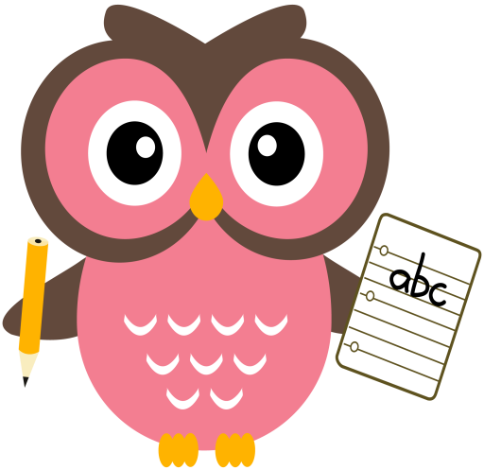

**Literacy**

This term we are continuing to read and write words containing long vowel sounds and introducing Block 3 tricky words.

**Word building:**

* Revision of the following sounds:

sh ch wh th ai/ay ee/ea igh/y oa/ow

(sound booklet to support)

* New sound – oa/ow

Suggested words: boat goal coat

bow show low

**Tricky words:**

* Revision of Block 1 and 2 tricky words.
* New tricky words Block 3:

so very every

**Maths**

* Practise counting forwards to 30 and beyond and backwards from 20. Try to start and stop at different numbers in the range.

(number line to support)

* Practise number formation.
* Order/sequence numbers within 20.

Challenge -100.

<https://www.topmarks.co.uk/ordering-and-sequencing/caterpillar-ordering>

**Term 2**

**2020**

**Comments**

Welcome back, I hope you all enjoyed the October holiday. Here are some activities which your child can practise at home. This is reinforcement of the learning taking place at school.

Suggested activities each week:

* Revision of sounds – sh, ch, th, wh, ai/ay, ee/ea, igh/y
* Choose 4 words containing oa/ow sounds to write in your jotter.
* One maths activity
* Read your story/follow-up Reading Task Map activity

Please can I ask that all reading books be returned on a Friday so that they can be quarantined before they are issued to another child.

Please do not hesitate to contact me if you have any questions regarding your child’s learning.

Thank you for your continued support and co-operation,

Mrs Taylor

**Reading**

* Read the story taking note of punctuation to read with fluency and expression.
* Go over speedy sounds.
* Choose one activity from Reading Task Map