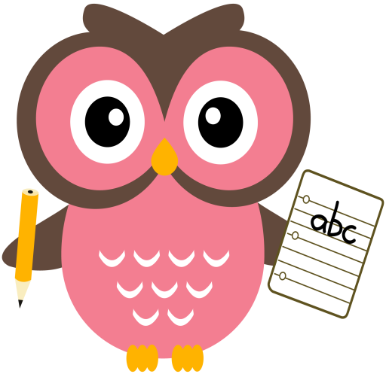

**Maths**

* Practise counting forwards and backwards up to number 20 and beyond if possible and starting at different numbers, not just 1.
* Practise number formation using the jotter and number strip.
* Practise counting amounts up to ten using 1-1 correspondence for example, buttons or counters.
* Join in with number rhymes

<https://www.bbc.co.uk/teach/school-radio/nursery-rhymes-counting-songs/zn67kmn>

**Literacy**

We are learning our sounds and how they are formed. In your child’s folder there are initial sound cards for them to practise wordbuilding. Examples of some words to practise are attached.

**Word building:**

* Revision of the following sounds:

a t p i s m r e h d o g

(see rhymes for letter formation)

* Can you identify each sound?
* Can you think of a word which begins with the sound? e.g t – train, s – snake.
* Can you remember the rhyme?

We will introduce 3 new sounds per week:

Monday f

Tuesday – u

Wednesday - b

Please find attached examples of words to practice.

Please see an example of word-building with the sounds on the following clip online:

<https://youtu.be/TkXcabDUg7Q>

**Term 2**

**2020**

**Comments**

Welcome back, I hope you all enjoyed the October holiday. Here are some activities which your child can practise at home. This is reinforcement of the learning taking place at school.

Suggested activites each week:

* Choose 3 words to make with your sounds.
* Can you form the sounds in your jotter?
* One maths activity
* Read your story

Please can I ask that all reading books be returned on a Friday so that they can be quarantined before they are issued to another child.

Please do not hesitate to contact me if you have any questions regarding your child’s learning.

Thank you for your continued support and co-operation,

Mrs Taylor

Thank you,

Mrs Taylor

**Reading**

Oxford Reading Tree Picture book

* Read the story
* Describe what you see.
* Point things out.
* Retell the story